**Crime Alert: An Anonymous Crime Reporting System**

*Submitted for partial fulfillment of the requirements*

*for the award of*

**BACHELOR OF TECHNOLOGY**

**in**

**COMPUTER SCIENCE ENGINEERING - ARTIFICIAL INTELLIGENCE & MACHINE LEARNING**

by

**Nandam Nagasivani** - **20BQ1A4239**

**Avula Srija Reddy** - **20BQ1A4204**

**Madduru Naga Sundeep** - **20BQ1A4232**

**Goddeti Vishnu Chaitanya** - **21BQ5A4202**

Under the guidance of

**K. Gnanendra, M. Tech**

**Assistant Professor**



**DEPARTMENT OF COMPUTER SCIENCE ENGINEERING - ARTIFICIAL INTELLIGENCE & MACHINE LEARNING**

**VASIREDDY VENKATADRI INSTITUTE OF TECHNOLOGY**

Permanently Affiliated to JNTU Kakinada, Approved by AICTE

Accredited by NAAC with ‘A’ Grade, ISO 9001:2008 Certified

NAMBUR (V), PEDAKAKANI (M), GUNTUR – 522 508

Tel no: 0863-2118036, url: www.vvitguntur.com

April 2024



**CERTIFICATE**

This is to certify that this **Project Report** is the bonafide work of **Ms. Nagasivani Nandam, Ms. Srija Reddy Avula, Mr. Naga Sundeep Madduru, Mr. Vishnu Chaitanya Goddeti** bearing Reg. No. **20BQ1A4239, 20BQ1A4204, 20BQ1A4232, 21BQ5A4202** respectivelywho had carried out the project entitled **“Crime Alert: An Anonymous Crime Reporting System"** under our supervision.

**Project Guide Head of the Department**

(Mr. K. Gnanendra, Assistant Professor) (Dr. K. Suresh Babu, Professor)

**Submitted for Viva voce Examination held on ____________________________**

**Internal Examiner External Examiner**

**DECLARATION**

We, Ms. Nagasivani Nandam, Ms. Srija Reddy Avula, Mr. Naga Sundeep Madduru, Mr. Vishnu Chaitanya Goddeti, hereby declare that the Project Report entitled **“****Crime Alert: An Anonymous Crime Reporting System”** done by us under the guidance of Mr. K. Gnanendra, Assistant Professor, Computer Science Engineering - Artificial Intelligence & Machine Learning at Vasireddy Venkatadri Institute of Technology is submitted for partial fulfillment of the requirements for the award of Bachelor of Technology in Computer Science Engineering - Artificial Intelligence and Machine Learning. The results embodied in this report have not been submitted to any other University for the award of any degree.

DATE :

PLACE :

SIGNATURE OF THE CANDIDATE (S)

**Nandam Nagasivani**

**Avula Srija Reddy**

**Madduru Naga Sundeep**

**Goddeti Vishnu Chaitanya**

**ACKNOWLEDGEMENT**

We take this opportunity to express my deepest gratitude and appreciation to all those people who made this project work easier with words of encouragement, motivation, discipline, and faith by offering different places to look to expand my ideas and helped me towards the successful completion of this project work.

First and foremost, we express my deep gratitude to **Mr. Vasireddy Vidya Sagar**, Chairman, Vasireddy Venkatadri Institute of Technology for providing necessary facilities throughout the B.Tech programme.

We express my sincere thanks to **Dr. Y. Mallikarjuna Reddy**, Principal, Vasireddy Venkatadri Institute of Technology for his constant support and cooperation throughout the B.Tech programme.

We express my sincere gratitude to **Dr. K. Suresh Babu**, Professor & HOD, Computer Science Engineering-Artificial Intelligence & Machine Learning, Vasireddy Venkatadri Institute of Technology for his constant encouragement, motivation and faith by offering different places to look to expand my ideas.

We would like to express my sincere gratefulness to our Guide **Mr. K. Gnanendra**, Assistant Professor, Computer Science Engineering-Artificial Intelligence & Machine Learningfor his insightful advice, motivating suggestions, invaluable guidance, help and support in successful completion of this project.

We would like to express our sincere heartfelt thanks to our Project Coordinator

**Mr. N. Balayesu**, Assistant Professor, Computer Science Engineering-Artificial Intelligence & Machine Learning, for his valuable advices, motivating suggestions, moral support, help and coordination among us in successful completion of this project.

We would like to take this opportunity to express my thanks to the **Teaching and Non-Teaching** Staff in the Department of Computer Science Engineering-Artificial Intelligence & Machine Learning, VVIT for their invaluable help and support.

**Name (s) of Students:**

**Nandam Nagasivani**

**Avula Srija Reddy**

**Madduru Naga Sundeep**

**Goddeti Vishnu Chaitanya**

**TABLE OF CONTENTS**

**CH No Title Page No**

Contents i

List of Figures iii

Abstract iv

**1 INTRODUCTION**

1.1 Background and Context 1

1.2 Motivation 2

1.3 Problem Statement 2

1.4 Objective of the Project 2

1.5 Scope 3

1.6 Project Introduction 3

1.7 Significance of the Study 4

1.8 Overview of the Project 4

**2 REVIEW OF LITERATURE**

2.1 Related Work 5

2.2 Current Trends and Technologies 6

in Crime Reporting Systems

2.3 Comparative Analysis of Existing Solutions 6

**3 ANALYSIS & DESIGN**

3.1 System Analysis 8

3.1.1 Overview of Existing Crime Reporting Systems 8

3.1.2 Identification of Limitations and Challenges 8

3.1.3 Proposed System 9

3.1.4 Advantages 9

3.1.5 Work Flow of Proposed System 10

3.2 Requirement Analysis10

3.2.1 Functional and Non-Functional Requirements 10

3.2.2 Hardware Requirements 11

3.2.3 Software Requirements 12

3.2.4 Architecture 12

3.3 Technologies Used 13

3.4 Algorithms 17

3.4.1 Convolutional Neural Networks (CNN) 17

3.4.2 Blockchain (Ethereum) 17

3.5 Integration Points and Use Cases 18

3.5.1 Utilization of CNN for False Alarm Detection 18

3.5.2 Incorporation of Blockchain 19

for Anonymous Tip Submission

3.6 System Design 21

3.7 UML Diagrams 23

**4 IMPLEMENTATION**

4.1 Environment Setup 30

4.1.1 Python 3.7.0 Installation 30

4.1.2 Node.js V12.13.1 Installation 31

**5 RESULTS**

5.1 Output Screens 39

**6 CONCLUTION AND FUTURE SCOPE** 52

**7 REFERENCES** 53

**APPENDIX**

Published Article Certificates 54

Published Article in the Journal 59

**LIST OF FIGURES**

**Figure No Figure Name Page No**

3.1 Work Flow of Proposed System 10

3.2 Proposed System Architecture 12

3.3 CNN algorithm for False Alarm Detection 18

3.4 Blockchain Architecture 20

3.5 Use Case Diagram 24

3.6 Class Diagram 24

3.7 Sequence Diagram 25

3.8 Collaborative Diagram 26

3.9 Deployment Diagram 26

3.10 Activity Diagram 27

3.11 Component Diagram 27

3.12 ER Diagram 28

3.13 DFD Level-1 Diagram 29

3.14 DFD Level-2 Diagram 29

4.1 Python Setup Wizard 30

4.2 SmartContract.sol File 32

4.3 Ethereum Startup 33

4.4 Contract Deployed 33

4.5 Contract Calling 34

4.6 Dataset Overview 35

4.7 IPFS Startup 35

4.8 Python Webserver Startup 36

5.1 Unique Id Generation 37

5.2 Prediction of the crime report 38

5.3TensorFlow CNN Metrics 38

**ABSTRACT**

The Crime Alert: An Anonymous Crime Reporting System represents a paradigm shift in the realm of crime reporting platforms, offering a comprehensive solution for secure and confidential reporting of criminal activities. Through the adept utilization of cutting-edge technologies, including Convolutional Neural Networks (CNN) for robust data analysis and Blockchain Ethereum for immutable and transparent record-keeping, the system ensures unparalleled levels of reliability and integrity. By guaranteeing anonymity for whistleblowers and witnesses, the platform empowers individuals to report crimes without fear of reprisal, thereby fostering a culture of accountability and community safety. Leveraging CNN algorithms, the system efficiently processes and analyzes reported data, facilitating the rapid categorization and identification of patterns within reported incidents. The integration of Blockchain Ethereum further enhances data integrity and transparency by establishing a tamper-proof ledger of reported crimes, thereby bolstering trust in the system's efficacy and reliability. Each report is meticulously cryptographically secured, preventing unauthorized access or alteration, and reinforcing the system's commitment to preserving user privacy and data security. In summary, the Crime Alert: An Anonymous Crime Reporting System stands as a beacon of trust and innovation, heralding a new era of transparency and accountability in combating criminal activities.

**Keywords:** Anonymous Crime Reporting, Convolutional Neural Networks, CNN, Blockchain Ethereum, Secure Reporting, Data Analysis, Anonymity, Transparency, Immutable Records, Whistleblower Protection.

**CHAPTER 1**

**INTRODUCTION**

**1.1 BACKGROUND AND CONTEXT:**In our world today, crime is a serious concern that affects the safety and well-being of communities. However, many people are afraid to report crimes because they worry about their safety or privacy being compromised. Traditional ways of reporting crimes often do not offer enough protection for those who want to help.

That's where the Crime Alert: An Anonymous Crime Reporting System comes in. It's a new and smart way for people to report crimes without revealing who they are. This system uses special technology like Convolutional Neural Networks (CNN) and Blockchain Ethereum to keep everything safe and private. With Crime Alert, people can feel safe reporting crimes without worrying about what might happen to them.The main idea behind Crime Alert is to make reporting crimes easier and safer for everyone involved. By using CNN algorithms, the system can quickly analyze the information people provide about crimes. This helps law enforcement understand patterns and trends in criminal activity, making it easier to catch criminals and keep communities safe.Another important feature of Crime Alert is its use of Blockchain Ethereum. This technology ensures that all the information reported about crimes is stored securely and cannot be changed by anyone. It's like having a digital lockbox where important information is kept safe from prying eyes.

Our aim with Crime Alert is to aid law enforcement in creating a safer country where crime information is reported without hesitation. Reports by the National Crime Records Bureau reveal that 750,000 complaints are annually registered under the Indian Penal Code, often due to insufficient evidence. Studies indicate that 60% of crimes remain unreported. Collaboration between law enforcement and the public is crucial to combat crime and ensure community safety. The police require public assistance to prevent crime, combat criminality, and foster a secure society.

Overall, the Crime Alert: An Anonymous Crime Reporting System aims to create a safer and more trustworthy environment for reporting crimes. By protecting the anonymity of those who report crimes and using advanced technology to analyze and store information securely, Crime Alert helps communities work together to combat crime and keep everyone safe.

**1.2 MOTIVATION:**

The motivation behind the Crime Alert: An Anonymous Crime Reporting System stems from the urgent need to overcome barriers in reporting criminal activities. By integrating advanced technologies like Convolutional Neural Networks (CNN) for data analysis and Blockchain Ethereum for immutable record-keeping, Crime Alert: An Anonymous Crime Reporting System aims to provide a secure, confidential, and transparent platform. Its primary motivation lies in ensuring whistleblower protection, fostering trust through anonymity, and enabling efficient categorization of reported incidents. This system addresses the critical gaps in traditional reporting systems by offering a secure and trustworthy channel for reporting crimes without fear of reprisal, ultimately enhancing community safety and law enforcement effectiveness.

**1.3 PROBLEM STATEMENT:**

Traditional crime reporting systems often lack anonymity and security, deterring individuals from reporting criminal activities due to fear of retaliation or lack of trust in the confidentiality of the process. This leads to underreporting, hindering law enforcement's ability to address and prevent crimes effectively. Furthermore, centralized databases are susceptible to tampering, raising concerns about data integrity and transparency.

**1.4 OBJECTIVE OF THE PROJECT:**

**1. Establish a secure and confidential platform:** Develop a user-friendly interface that allows individuals to report criminal activities anonymously, ensuring their safety from potential reprisals.

**2. Implement CNN for data analysis:** Utilize advanced algorithms to process and analyze reported data, enabling efficient categorization and identification of patterns within incidents.

**3. Integrate Blockchain Ethereum for transparency and immutability:** Create a tamper-proof ledger of reported crimes, ensuring data integrity and transparency while preventing unauthorized access or modifications.

**4. Ensure whistleblower protection:** Safeguard the anonymity of whistleblowers and witnesses, encouraging them to report crimes without fear of exposure or retaliation.

**5. Foster trust in the reporting system**: Build a robust and reliable system that instills confidence in users, encouraging them to actively participate in reporting criminal activities without hesitation or distrust.

**1.5 SCOPE:**

The scope of the Crime Alert: An Anonymous Crime Reporting System encompasses the creation of a secure, confidential, and technologically advanced platform for reporting criminal activities. It involves the implementation of Convolutional Neural Networks (CNN) for robust data analysis and the integration of Blockchain Ethereum for immutable and transparent record-keeping. The system aims to ensure anonymity for whistleblowers and witnesses, fostering an environment where individuals can report crimes without fear of retaliation. The scope also involves the development of algorithms that efficiently process and categorize reported data to identify patterns within incidents. It extends to the establishment of a tamper-proof ledger using Blockchain Ethereum, ensuring data integrity and preventing unauthorized access or alterations. The primary focus is to create a trustworthy and secure environment that encourages reporting while safeguarding the anonymity of those involved.

**1.6 PROJECT INTRODUCTION:**

In an era marked by technological advancements, the need for a secure, confidential, and reliable system for reporting criminal activities has never been more pronounced. The Crime Alert: An Anonymous Crime Reporting System stands at the forefront of innovation, offering a pioneering solution to address this pressing societal need. Crime Alert: An Anonymous Crime Reporting System represents a paradigm shift in the way criminal incidents are reported and managed. It leverages cutting-edge technologies, notably Convolutional Neural Networks (CNN) for meticulous data analysis and Blockchain Ethereum for unassailable record-keeping, to create an ecosystem that ensures anonymity, integrity, and transparency in crime reporting. The core ethos of Crime Alert: An Anonymous Crime Reporting System revolves around providing a safe avenue for whistleblowers and witnesses to report criminal acts without the fear of retaliation or exposure. By enabling individuals to share crucial information anonymously, the system empowers them to contribute to the safety and security of their communities without compromising their safety.

The utilization of CNN algorithms within the system allows for the intricate processing and examination of reported data. This technological backbone enables the efficient categorization of incidents and the identification of recurring patterns, facilitating a deeper understanding of the dynamics of reported crimes. Moreover, the integration of Blockchain Ethereum technology plays a pivotal role in ensuring the immutability and transparency of the reported data. By harnessing the power of this decentralized ledger, Crime Alert: An Anonymous Crime Reporting System establishes an unalterable record of reported crimes, safeguarding against unauthorized access or tampering. This robust security measure fosters trust among users, stakeholders, and authorities in the veracity of the reported information. In essence, Crime Alert: An Anonymous Crime Reporting System heralds a new era in crime reporting, where cutting-edge technologies converge to uphold anonymity, data integrity, and transparency. It not only revolutionizes the process of reporting criminal activities but also serves as a beacon of trust and reliability in the pursuit of a safer and more just society.

**1.7 SIGNIFICANCE OF THE STUDY:**

The Crime Alert: An Anonymous Crime Reporting System is really important because it helps people report crimes in a safe and confidential way. This is a big deal because many traditional ways of reporting crimes don't keep people's identity secret, which can make them scared to report. By using fancy technology like Convolutional Neural Networks (CNN) and Blockchain Ethereum, this system keeps people anonymous and makes sure the information they provide is safe from being changed or seen by the wrong people. It's like having a secret box where you can share important information about crimes without anyone knowing who you are. This helps make communities safer and helps police do their job better.

**1.8 OVERVIEW OF THE PROJECT**:

The Crime Alert: An Anonymous Crime Reporting System is a smart way to report crimes without worrying about your identity being revealed. It uses special technology like Convolutional Neural Networks (CNN) and Blockchain Ethereum to keep everything safe and private. With this system, people can report crimes without being afraid of what might happen to them. It's like having a secret helper who keeps your information safe while still helping to catch bad guys. This project is a big step towards making reporting crimes easier and safer for everyone involved.

**CHAPTER 2**

**LITERATURE SURVEY**

**2.1 RELATED WORK:**

**[1] B. Holtmann, and Domingo-Swarts, “Current trends and responses to crime in South Africa. Crime,” Violence and Injury Prevention in South Africa, 2008, pp 105 - 129.**

It reveals a complex landscape marked by high levels of crime, necessitating a multifaceted approach to violence and injury prevention. The research underscores the urgent need for effective strategies, highlighting the importance of community engagement and law enforcement collaboration. The study emphasizes the role of socio-economic factors and their impact on crime rates, advocating for targeted interventions to address underlying issues. Overall, the outcomes underscore the significance of comprehensive, evidence-based initiatives to combat crime and enhance safety in the South African context.

**[2] Diva Lal, Adiba Abidin, Naveen Garg, and Vikas Deep. “Advanced immediate crime reporting to police in India.” Procedia Computer Science, 85:543–549, 2016.**

The implementation of advanced systems streamlines the reporting process, leading to quicker response times from law enforcement. Additionally, the study underscores the potential for increased public participation in crime reporting, contributing to a more responsive and proactive policing environment. The findings emphasize the positive impact of leveraging technology to augment crime reporting mechanisms, ultimately fostering a safer and more secure society in India.

**[3] Tzay-Farn Shih, Chin-Ling Chen, Bo-Yan Syu, andYong-Yuan Deng. A cloud-based crime reporting system with identity protection. Symmetry, 11(2):255, 2019.**

The implementation demonstrated enhanced security through identity protection measures, ensuring the confidentiality of reporters. Utilizing cloud technology improved accessibility and scalability, allowing users to submit reports seamlessly. The system's design, leveraging symmetry principles, contributed to a harmonized and efficient reporting process. The recorded outcomes showcased an advancement in user trust, encouraging individuals to engage in crime reporting. Overall, the study demonstrated the viability of a cloud-based approach with identity protection, offering a secure and user-friendly platform for reporting criminal incidents.

**[4] Kovács, L., Szlávik, Z., Benedek, C., Havasi, L., Petrás, I., Losteiner, D., Utasi, Á., Liscár, A., Czúni, L. and Szirányi, T., “Video Surveillance Framework for Crime Prevention and Event Indexing,” in ICT4Justice, January 2008.**

The system employs advanced algorithms for event indexing, aiding in efficient crime detection and analysis. Through intelligent video processing, it enables automated monitoring and identification of potential threats. The proposed framework not only contributes to crime prevention but also facilitates the systematic categorization and retrieval of relevant events. This research offers a valuable ICT tool for law enforcement, providing a proactive approach to enhance public safety through effective video surveillance and event indexing.

**2.2 CURRENT TRENDS AND TECHNOLOGIES IN CRIME REPORTING SYSTEMS:**

In recent years, there has been a significant evolution in crime reporting systems, driven by advancements in technology and changing societal needs. One notable trend is the increasing adoption of digital platforms and mobile applications for reporting crimes. These platforms offer convenient and accessible channels for individuals to report incidents, often enabling real-time communication with law enforcement agencies.Moreover, there is a growing emphasis on enhancing the anonymity and confidentiality of crime reporting processes. Anonymous reporting systems leverage encryption techniques and secure communication protocols to protect the identity of whistleblowers and witnesses, thereby encouraging more people to come forward with valuable information.Another emerging trend is the integration of artificial intelligence (AI) and machine learning algorithms in crime reporting systems. These technologies enable automated analysis of reported incidents, allowing law enforcement agencies to identify patterns, detect anomalies, and prioritize responses more effectively. Additionally, AI-powered chatbots and virtual assistants are being employed to provide immediate assistance to individuals reporting crimes, enhancing user experience and response times.Blockchain technology has also gained traction in crime reporting systems, offering tamper-resistant and transparent record-keeping capabilities. By leveraging blockchain-based platforms, authorities can ensure the integrity and immutability of reported data, reducing the risk of data manipulation or tampering.Furthermore, there is a growing recognition of the importance of community engagement and collaboration in crime prevention and reporting. Social media platforms and community-oriented applications are being utilized to facilitate information sharing, community policing initiatives, and empowering citizens to play an active role in maintaining public safety.

**2.3 COMPARATIVE ANALYSIS OF EXISTING SOLUTIONS**:In comparing traditional crime reporting methods, internet-based systems, and camera surveillance with the new Crime Alert: An Anonymous Crime Reporting System, several distinctions emerge. Traditional approaches, like reporting to authorities directly, often lack mechanisms to ensure reporter anonymity, potentially dissuading individuals from coming forward due to fears of reprisal. In contrast, internet-based platforms offer improved anonymity through encryption and secure channels, making it safer for whistleblowers to report crimes without fear of exposure. However, camera surveillance systems, while effective in providing visual evidence, may not prioritize protecting reporters' identities, focusing primarily on capturing events rather than ensuring anonymity.When it comes to data analysis capabilities, traditional methods and camera surveillance systems may struggle to efficiently process and analyze reported data to discern patterns or trends in criminal activities. Internet-based systems typically fare better, utilizing basic analytics tools to understand collected data. Nevertheless, the Crime Alert system excels by employing advanced technologies such as Convolutional Neural Networks (CNN) for robust data analysis. This enables quick identification of patterns within reported incidents, enhancing the system's capacity to categorize and analyse crime reports effectively, providing valuable insights for law enforcement and community safety.In terms of transparency and reliability, traditional methods and camera surveillance systems may face challenges in ensuring data integrity and trustworthiness due to centralized storage and potential tampering. Internet-based systems mitigate these concerns by employing decentralized storage and immutable records, enhancing trust in reported information. However, the Crime Alert system surpasses existing solutions by leveraging Blockchain Ethereum technology for transparent and tamper-proof record-keeping. This ensures data integrity and reliability, instilling confidence among users, stakeholders, and law enforcement agencies in the accuracy and authenticity of reported crime information

**CHAPTER 3**

**ANALYSIS & DESIGN**

**3.1 SYSTEM ANALYSIS**

**3.1.1 OVERVIEW OF EXISTING CRIME REPORTING SYSTEMS**

Existing crime reporting systems often lack robust mechanisms for ensuring the anonymity and security of individuals reporting criminal activities. Traditional systems often rely on manual reporting methods, which may deter whistleblowers and witnesses due to concerns about potential reprisals or breaches of confidentiality. These systems might also lack advanced data analysis tools, making it challenging to efficiently categorize and identify patterns within reported incidents. Furthermore, the absence of secure record-keeping methods could compromise the integrity and transparency of reported data, leading to potential tampering or unauthorized access.

**3.1.2** **IDENTIFICATION OF LIMITATIONS AND CHALLENGES:**

**1. Lack of Anonymity:** Many existing systems fail to provide adequate anonymity to whistleblowers and witnesses, discouraging individuals from reporting crimes due to fear of retaliation or exposure.

**2. Insufficient Security Measures:** Traditional reporting systems often lack robust security measures, making them vulnerable to data breaches, hacking attempts, or unauthorized access, compromising the confidentiality of reported information.

**3. Limited Data Analysis Capabilities:** These systems may lack advanced technologies like machine learning or neural networks, making it challenging to analyze reported data efficiently and identify crucial patterns or trends in criminal activities.

**4. Vulnerability to Tampering:** Without proper record-keeping mechanisms, existing systems are susceptible to data tampering or alterations, undermining the integrity and reliability of reported crime information.

**5. Lack of Transparency:** The absence of transparent and immutable record-keeping methods can result in a lack of trust in the reported data's accuracy and authenticity, leading to scepticism among users and authorities regarding the reliability of the system.

**3.1.3 PROPOSED SYSTEM**

The Crime Alert: An Anonymous Crime Reporting System is a cutting-edge solution poised to revolutionize the landscape of crime reporting. This innovative platform is designed with a primary focus on security and confidentiality, enabling individuals to report criminal activities without the fear of exposure or retaliation. Utilizing advanced technologies like Convolutional Neural Networks (CNN) for intricate data analysis and Blockchain Ethereum for immutable record-keeping, the Crime Alert: An Anonymous Crime Reporting System ensures anonymity for whistleblowers and witnesses. Through the integration of CNN algorithms, the system efficiently processes and categorizes reported data, allowing for the identification of patterns within incidents. Meanwhile, the incorporation of Blockchain Ethereum guarantees data integrity and transparency, establishing an unalterable ledger of reported crimes, fostering trust and reliability in the system's operations.

**3.1.4 ADVANTAGES**

**1. Anonymity Protection:** The system prioritizes whistleblower safety by providing a secure environment for reporting, safeguarding identities and enabling individuals to disclose criminal activities without fear of retaliation.

**2. Efficient Data Analysis:** Leveraging CNN algorithms, the Crime Alert: An Anonymous Crime Reporting System can swiftly process and categorize vast amounts of reported data, facilitating quicker identification of patterns and trends within criminal incidents.

**3. Immutable Record-Keeping:** Utilizing Blockchain Ethereum technology ensures that reported crime data remains tamper-proof and transparent. This fosters trust among users and stakeholders regarding the integrity of the information stored.

**4. Transparency and Trust:** The system's use of Blockchain technology promotes transparency, creating a clear and verifiable trail of reported incidents. This transparency enhances trust among users, law enforcement agencies, and the community.

**5. Robust Security Measures:** With cryptographic security measures in place, unauthorized access or alterations to reported data are prevented, ensuring the system's resilience against potential cyber threats or tampering attempts, thereby maintaining the credibility

**3.1.5 WORK FLOW OF PROPOSED SYSTEM** 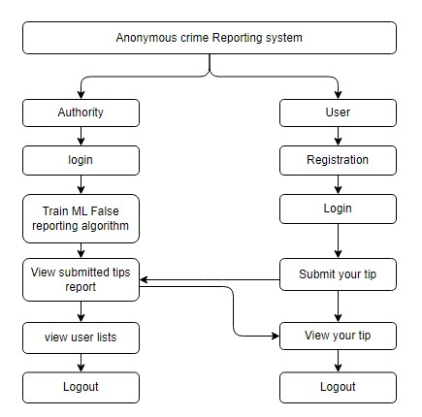

Fig:3.1 Work Flow of Proposed System

**3.2 REQUIREMENT ANALYSIS**

**3.2.1 FUNCTIONAL AND NON-FUNCTIONAL REQUIREMENTS**

Requirement’s analysis is very critical process that enables the success of a system or software project to be assessed. Requirements are generally split into two types: Functional and non-functional requirements.

**Functional Requirements**: These are the requirements that the end user specifically demands as basic facilities that the system should offer. All these functionalities need to be necessarily incorporated into the system as a part of the contract. These are represented or stated in the form of input to be given to the system, the operation performed and the output expected. They are basically the requirements stated by the user which one can see directly in the final product, unlike the non-functional requirements.

Examples of functional requirements:

1. Authentication of user whenever he/she logs into the system
2. System shutdown in case of a cyber-attack
3. A verification email is sent to user whenever he/she registers for the first time on some software system.

**Non-functional requirements**: These are basically the quality constraints that the system must satisfy according to the project contract. The priority or extent to which these factors are implemented varies from one project to other. They are also called non-behavioral requirements.

They basically deal with issues like:

* Portability
* Security
* Maintainability
* Reliability
* Scalability
* Performance
* Reusability
* Flexibility

Examples of non-functional requirements:

1. Emails should be sent with a latency of no greater than 12 hours from such an activity.
2. The processing of each request should be done within 10 seconds
3. The site should load in 3 seconds whenever of simultaneous users are > 10000

**3.2.2 HARDWARE REQUIREMENTS:**

Processor - I3/Intel Processor

Hard Disk - 160GB

Key Board - Standard Windows Keyboard

Mouse - Two or Three Button Mouse

Monitor - SVGA

RAM - 8GB

* + 1. **SOFTWARE REQUIREMENTS:**

Frontend - HTML5/CSS, JavaScript, Bootstrap, Node-js

Programming languages - Solidity Programming, Python

Backend & Database - Django, SQLIte

Blockchain Ecosystem - Ethereum

Frameworks - TensorFlow, Truffle, Keras, Django

Library - Scikit-learn, Pandas, NumPy, NLTK, Web3

Version control system - Git, Github

Testing Framework - Selenium

User Interface Design Tools - Figma

Deploying Platform - AWS/Azure

**3.2.4 ARCHITECTURE:**

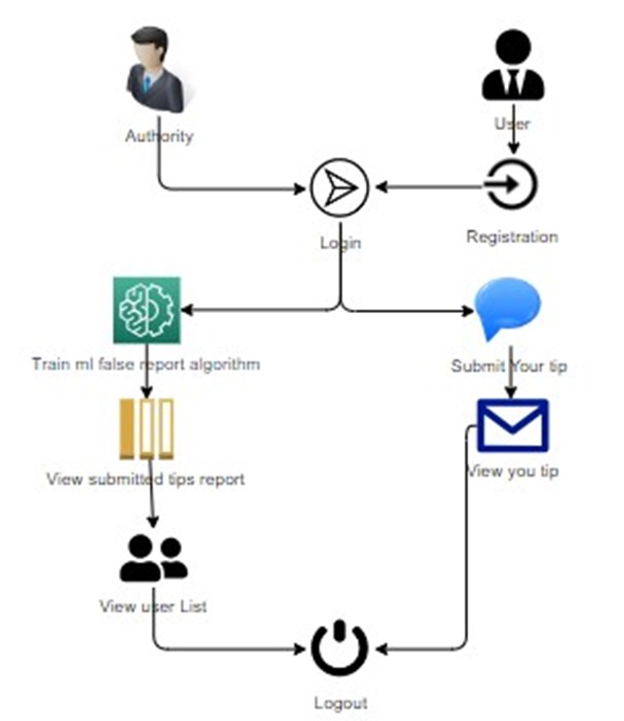

Fig:3.2 Proposed System Architecture

**3.3 TECHNOLOGIES USED**

**Frontend Technologies:**

**HTML** (Hypertext Markup Language): HTML is the standard markup language for creating web pages and applications. It provides the structure and layout for web content, using elements and tags to define different parts of a webpage such as headings, paragraphs, links, and images. In the Crime Alert system, HTML is utilized to create the user interface, defining the layout and structure of the reporting platform.**CSS** (Cascading Style Sheets): CSS is a style sheet language used to enhance the presentation of HTML documents. It allows developers to customize the appearance of web pages by specifying styles such as colors, fonts, spacing, and layout. In the Crime Alert system, CSS is employed to apply styles to HTML elements, ensuring a visually appealing and user-friendly interface for reporting criminal activities.

**Bootstrap:** Bootstrap is a popular front-end framework that simplifies the process of designing responsive and mobile-first websites. It provides pre-designed components and CSS stylesheets that developers can use to create consistent and visually appealing interfaces across different devices and screen sizes. In the Crime Alert system, Bootstrap is utilized to enhance the responsiveness and accessibility of the reporting platform, ensuring optimal user experience on various devices.**JavaScript (JS):** JavaScript is a versatile programming language commonly used for adding interactivity and dynamic behaviour to web pages. It enables developers to create interactive elements, handle user input, manipulate the DOM (Document Object Model), and communicate with backend servers asynchronously. In the Crime Alert system, JavaScript is employed to implement interactive features such as form validation, real-time updates, and user feedback, enhancing the functionality and usability of the reporting platform.

**Node.js:** Node.js is an open-source, cross-platform runtime environment for executing JavaScript code on the server side. It enables developers to build scalable and high-performance server-side applications using JavaScript, taking advantage of its non-blocking, event-driven architecture.

**Backend Technologies:**

**Python:** Python is a high-level, interpreted programming language known for its simplicity, readability, and versatility. It is widely used for backend web development due to its extensive libraries, frameworks, and support for various programming paradigms. In the context of this project, Python is used for implementing machine learning algorithms, handling data processing, and managing server-side logic.**SQLite:** SQLite is a small and easy-to-use database system that doesn't need a separate server. It stores data directly in a single file on your device. You can use it to organize and manage information for your crime alert project, like details about incidents, suspects, and locations. It follows standard SQL commands, making it simple to learn and use. Despite being lightweight, it supports essential features like transactions and data integrity. SQLite is great for projects with limited resources or when you want a quick and straightforward way to store and retrieve data. Its simplicity and portability make it a popular choice for many applications

**Django**: Django is a high-level, open-source Python web framework that encourages rapid development and clean, pragmatic design. Built on the Model-View-Template (MVT) architectural pattern, it simplifies the process of creating complex web applications by providing a rich set of built-in components and tools. Django promotes best practices, including separation of concerns, reusability, and maintainability, and offers an extensive range of features, such as an Object-Relational Mapper (ORM) system, an admin interface, and authentication mechanisms. Its simplicity and scalability make it an ideal choice for both small projects and large-scale, enterprise-level web applications

**Blockchain Ecosystem**

**Ethereum:** Ethereum, as an open-source, blockchain-based, decentralized software platform, serves as the foundation for the Crime Alert: An Anonymous Crime Reporting System. It enables the creation and execution of Smart Contracts, which form the backbone of the secure tip reporting and verification process. Ethereum's blockchain technology ensures the immutability and transparency of the reported data, making it a reliable and trustworthy system for anonymous crime tip reporting.

**Solidity:** Solidity, a contract-oriented, high-level programming language, is used to write Smart Contracts for Ethereum in the Crime Alert system. It provides static typing, explicit modeling, and features such as inheritance, libraries, and complex user-defined types, which contribute to the creation of modular and reusable Smart Contracts. By employing Solidity in the project, the system can maintain secure and automated tip reporting and verification processes, ensuring the anonymity and security of tip submitters while maintaining the integrity and transparency of the reported data.

**Frameworks:**

**TensorFlow:** TensorFlow is an open-source machine learning and deep learning framework developed by Google. It provides a comprehensive ecosystem of tools, libraries, and community resources for training, deploying, and scaling machine learning models across various platforms and architectures.

**Truffle:** Truffle is a development framework for Ethereum Smart Contracts. It provides a suite of tools and features for compiling, deploying, and testing Solidity contracts, including a local development blockchain, automated contract deployment, and a scriptable configuration system**.**

**Keras:** Keras is a high-level neural networks API, written in Python and capable of running on top of TensorFlow, Theano, or Microsoft Cognitive Toolkit (CNTK). It provides a user-friendly interface for building and training deep learning models, with support for both convolutional and recurrent neural networks. Keras emphasizes simplicity, flexibility, and extensibility, making it suitable for beginners and experienced practitioners alike.

**Libraries:**

**Scikit-learn:** Scikit-learn is a Python library for machine learning, specifically designed for data mining and data analysis. It provides a wide range of algorithms, tools, and functionalities for classification, regression, clustering, and dimensionality reduction, accessible through a simple and consistent interface. It is built on top of NumPy, SciPy, and matplotlib, making it easy to integrate into existing Python workflows. scikit-learn plays a crucial role in the Crime Alert system by enabling the development of robust and accurate machine learning models for predicting and identifying crime patterns thereby enhancing public safety and security.

**Pandas:** Pandas is a powerful data manipulation and analysis library for Python, commonly used for handling structured data such as tables and time series. It provides data structures like Data Frame and Series, along with functions for data cleaning, transformation, aggregation, and visualization. In the Crime Alert system, Pandas is employed for processing and analysing reported crime data, enabling efficient categorization, pattern recognition, and trend identification.

**NumPy:** NumPy is a fundamental library for scientific computing in Python, providing support for multidimensional arrays, mathematical functions, and linear algebra operations. It offers efficient data storage and manipulation capabilities, along with tools for numerical analysis, statistical modeling, and machine learning. In the Crime Alert system, NumPy is used for numerical computations, statistical analysis, and machine learning algorithms applied to crime data processing and analysis.

**NLTK:** NLTK (Natural Language Toolkit) is a leading platform for building Python programs that work with human language data. It provides easy-to-use interfaces to over 50 corpora and lexical resources, along with a suite of text processing libraries for tokenization, parsing, and semantic reasoning.

**Web3.py**: Web3.py is a Python library for interacting with Ethereum, providing an easy-to-use interface for connecting to Ethereum nodes, executing transactions, and interacting with Smart Contracts. It serves as a bridge between Python applications and the Ethereum blockchain, enabling seamless integration and communication.Web3.py simplifies the process of building Ethereum-based applications by providing a high-level API for interacting with smart contracts and blockchain data.

**IPFS (InterPlanetary File System)**: IPFS is a decentralized, content-addressable, and peer-to-peer file system protocol designed to store and share hypermedia in a distributed manner. It aims to provide a more efficient, secure, and resilient alternative to traditional HTTP-based web architectures by utilizing a unique combination of content-addressing, block exchange, and versioning. In the context of the Crime Alert: An Anonymous Crime Reporting System, IPFS can be employed to store and distribute large files, such as multimedia evidence, associated with crime reports securely and efficiently.

**PyAES:** PyAES is a Python library that provides an implementation of AES (Advanced Encryption Standard), a symmetric encryption algorithm widely recognized for its high level of security and efficiency. In the context of the Crime Alert system, PyAES can be employed to encrypt and decrypt sensitive information, such as user data, ensuring the confidentiality and integrity of the information exchanged between the system and its users.

**PBKDF2 (Password-Based Key Derivation Function 2):** PBKDF2 (Password-Based Key Derivation Function 2) is a password-hashing method that uses an iterative process to generate a cryptographic key from a password or passphrase. The function aims to mitigate the risk of brute-force attacks by introducing computational complexity, making it harder and more time-consuming to crack the derived key.

These technologies collectively form the backbone of the Crime Alert system, enabling the development of a secure, efficient, and user-friendly platform for reporting criminal activities, analysing crime data, and ensuring transparency and accountability in the reporting process.

* 1. **ALGORITHMS:**

**3.4.1 CONVOLUTIONAL NEURAL NETWORK (CNN):**

Convolutional Neural Network (CNN) is a type of deep learning model commonly utilized for various tasks in computer vision, natural language processing, and sequential data analysis. CNN have been successfully applied to various natural language processing tasks, including text classification, sentiment analysis, and language translation. In text classification, for instance, CNN can effectively analyze textual data by learning meaningful patterns and relationships between words or phrases. By processing input text through multiple convolutional and pooling layers, CNN can capture important linguistic features and contextual information, enabling accurate classification of text into different categories or labels. The hierarchical nature of CNN architectures allows them to learn complex representations of text data, making them particularly adept at handling tasks that involve analyzing sequential information. With their versatility and capability to automatically learn from data, CNN continue to be at the forefront of research and development in the field of deep learning and artificial intelligence.

**3.4.2 BLOCKCHAIN (ETHEREUM):**

Blockchain is a decentralized and distributed ledger technology that enables the secure and transparent recording of transactions across a network of computers. Ethereum is a blockchain platform that extends the functionality of traditional blockchain by introducing smart contracts, which are self-executing contracts with predefined conditions written in code.

In Ethereum's blockchain, each block contains a list of transactions, and every block is linked to the previous one, forming a chronological chain of blocks. This linkage, along with cryptographic hashing and consensus mechanisms, ensures the immutability and security of the data recorded on the blockchain. Ethereum's smart contracts enable the execution of complex logic and the creation of decentralized applications (DApps) that operate autonomously and transparently without the need for intermediaries.**3.5 INTEGRATION POINTS AND USE CASES**

**3.5.1 UTILIZATION OF CNN FOR FALSE ALARM DETECTION**

Utilizing Convolutional Neural Networks (CNNs) in the Crime Alert: An Anonymous Crime Reporting System focuses primarily on text-related tasks, particularly in detecting false alarms within reported incidents. Initially, the text descriptions undergo preprocessing to eliminate stop words, punctuation, and other irrelevant information, ensuring that only useful features are retained. Subsequently, these pre-processed descriptions are converted into numerical representations through word embedding, capturing the semantic meaning of words and their relationships within the text.

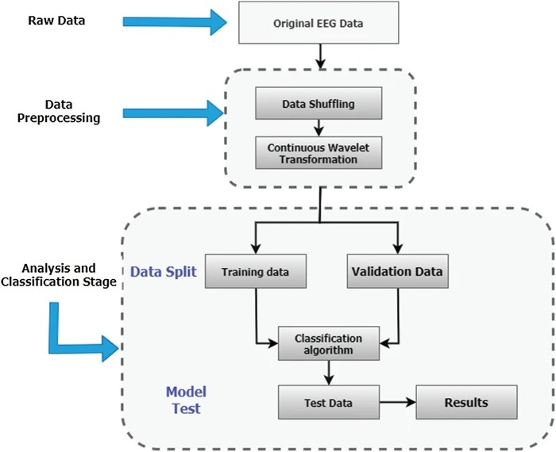

Fig:3.3 CNN algorithm for False Alarm Detection

**Data Preprocessing**:The text descriptions in the dataset undergo preprocessing to remove stop words, punctuation, and other irrelevant information, ensuring that only useful features are retained. This initial preprocessing step enhances the quality and relevance of the text data for subsequent analysis.

**Word Embedding**:Following preprocessing, the text descriptions are converted into numerical representations through word embedding. This process captures the semantic meaning of words and their relationships within the text, facilitating deeper analysis by the CNN model. By embedding the preprocessed text descriptions into numerical vectors, the CNN can effectively analyze and interpret the textual data.

**Data Split:**The preprocessed and embedded text descriptions are then divided into training, validation, and test datasets. The training dataset is utilized to train the CNN model, where it learns to extract pertinent features from the text descriptions. This data splitting ensures that the model is trained on a diverse set of examples and prevents overfitting to the training data.

**CNN Model:**A CNN model is trained on the embedded text descriptions to classify the reports as genuine or false. Through a series of convolutional and pooling layers, the CNN identifies intricate patterns and characteristics indicative of genuine criminal activities. The extracted features are then fed into fully connected layers for classification, enabling the CNN model to discern between genuine and false alarms based on the patterns learned during training. The model's performance is evaluated using a separate validation dataset, computing metrics such as accuracy, precision, recall, and F1 score to assess its effectiveness in accurately identifying false alarms. This meticulous process ensures the reliability and robustness of the CNN model in enhancing the accuracy of the Crime Alert system.

**3.5.2 INCORPORATION OF BLOCKCHAIN FOR ANONYMOUS TIP SUBMISSION**

The Crime Alert system integrates Blockchain Ethereum technology to facilitate secure and anonymous tip submission, ensuring the confidentiality and integrity of the reported information. Blockchain serves as the foundation for creating a tamper-proof and transparent ledger of reported crimes, safeguarding against unauthorized access or alterations while maintaining anonymity for whistleblowers.

**Key Features:Immutable Ledger:** Each tip report is cryptographically hashed and added to the Ethereum blockchain, creating an immutable record that cannot be modified or tampered with. This ensures the integrity and transparency of the reported data.**Anonymity Protection:** Blockchain technology allows users to submit tips anonymously without revealing their identities. User anonymity is preserved throughout the submission process, fostering a safe and confidential environment for reporting criminal activities.**Decentralized Architecture:** The decentralized nature of Blockchain Ethereum eliminates the need for a central authority or intermediary, reducing the risk of data manipulation or corruption. This enhances trust in the reporting system among users and stakeholders.**Transparent Verification:** Tip reports stored on the blockchain can be transparently verified by authorized parties, ensuring the authenticity and reliability of the information. This transparency promotes accountability and trust in the reported data.

**Ethereum** is used primarily for secure and transparent data storage through its blockchain technology.

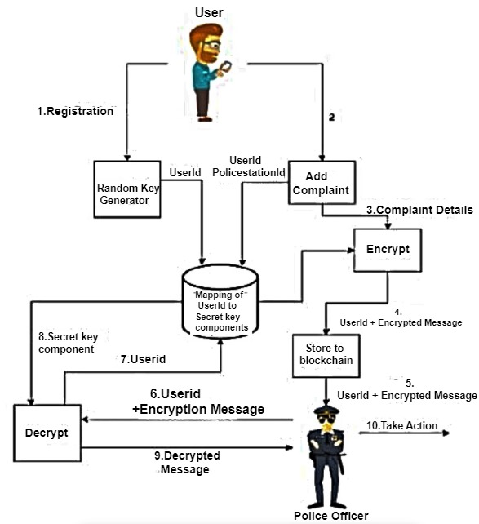

Fig:3.4 Blockchain Architecture

* **Registration:** Ethereum is not directly involved in the registration process of generating random keys and creating secret key components. This step is primarily focused on ensuring user anonymity.
* **User id Generation:** Similarly, Ethereum is not directly involved in generating User ids. This step mainly involves creating unique identifiers for users, which are mapped to their secret key components.
* **Encrypted Message Sending:**Ethereum is not directly involved in the encryption and sending of messages. Users encrypt messages using their secret key components, ensuring secure transmission to the system.
* **Decryption:** Ethereum does not participate in the decryption process. The system decrypts received messages using the appropriate secret key components, which were generated during registration.
* **Complaint Details Storage:**Here is where Ethereum comes into play. And stored on a blockchain, associated with the user's Userid, ensuring data integrity and transparency.

The Crime Alert: An Anonymous Crime Reporting System leverages Ethereum's blockchain technology to ensure secure and transparent crime reporting. Smart contracts on the Ethereum blockchain facilitate the creation of immutable and tamper-proof records for reported incidents. Each report is timestamped, encrypted, and linked to a unique identifier, enhancing anonymity while maintaining data integrity. Ethereum's decentralized nature eliminates the need for a central authority, reducing the risk of corruption.

Additionally, the system employs cryptographic techniques for secure user identification, providing a reliable and confidential channel for reporting crimes. This innovative blockchain solution fosters trust and accountability in crime reporting, paving the way for a safer and more secure community

**3.6 SYSTEM DESIGN**

**INTRODUCTION OF INPUT DESIGN:**

In an information system, input is the raw data that is processed to produce output. During the input design, the developers must consider the input devices such as PC, MICR, OMR, etc.

Therefore, the quality of system input determines the quality of system output. Well-designed input forms and screens have following properties −

* It should serve specific purpose effectively such as storing, recording, and retrieving the information.
* It ensures proper completion with accuracy.
* It should be easy to fill and straightforward.
* It should focus on user’s attention, consistency, and simplicity.
* All these objectives are obtained using the knowledge of basic design principles regarding−
  + What are the inputs needed for the system?
  + How end users respond to different elements of forms and screens.

### **Objectives for Input Design:**

The objectives of input design are −

* To design data entry and input procedures
* To reduce input volume
* To design source documents for data capture or devise other data capture methods
* To design input data records, data entry screens, user interface screens, etc.
* To use validation checks and develop effective input controls.

**Output Design:**

The design of output is the most important task of any system. During output design, developers identify the type of outputs needed, and consider the necessary output controls and prototype report layouts.

### **Objectives of Output Design**:

The objectives of input design are:

* To develop output design that serves the intended purpose and eliminates the production of unwanted output.
* To develop the output design that meets the end user’s requirements.
* To deliver the appropriate quantity of output.
* To form the output in appropriate format and direct it to the right person.
* To make the output available on time for making good decisions.

**3.7 UML DIAGRAMS:**

UML stands for Unified Modelling Language. UML is a standardized general-purpose modelling language in the field of object-oriented software engineering. The standard is managed, and was created by, the Object Management Group.

The goal is for UML to become a common language for creating models of object-oriented computer software. In its current form UML is comprised of two major components: a Meta-model and a notation. In the future, some form of method or process may also be added to; or associated with, UML.

The Unified Modelling Language is a standard language for specifying, Visualization, Constructing and documenting the artifacts of software system, as well as for business modelling and other non-software systems.

The UML represents a collection of best engineering practices that have proven successful in the modelling of large and complex systems.

The UML is a very important part of developing objects-oriented software and the software development process. The UML uses mostly graphical notations to express the design of software projects.

**GOALS:**

The Primary goals in the design of the UML are as follows:

1. Provide users a ready-to-use, expressive visual modelling Language so that they can develop and exchange meaningful models.
2. Provide extendibility and specialization mechanisms to extend the core concepts.
3. Be independent of particular programming languages and development process.
4. Provide a formal basis for understanding the modelling language.
5. Encourage the growth of OO tools market.
6. Support higher level development concepts such as collaborations, frameworks, patterns and components.
7. Integrate best practices.

**USE CASE DIAGRAM**

* A use case diagram in the Unified Modeling Language (UML) is a type of behavioral diagram defined by and created from a Use-case analysis.
* Its purpose is to present a graphical overview of the functionality provided by a system in terms of actors, their goals (represented as use cases), and any dependencies between those use cases.
* The main purpose of a use case diagram is to show what system functions are performed for which actor. Roles of the actors in the system can be depicted.

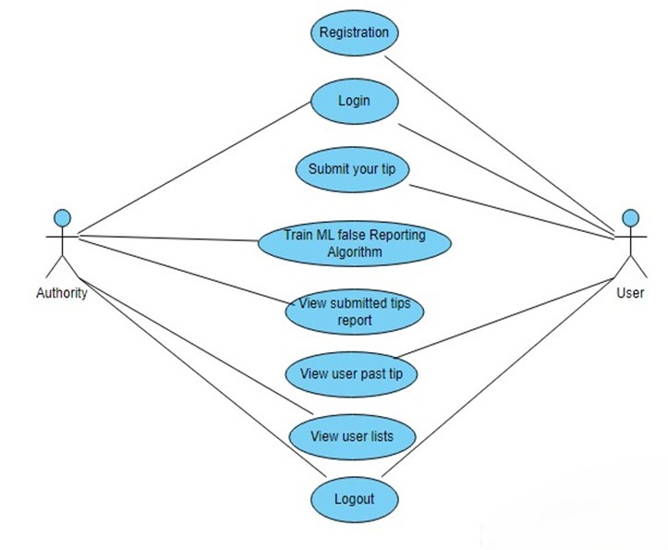

Fig:3.5 Use Case Diagram

**CLASS DIAGRAM**

In software engineering, a class diagram in the Unified Modeling Language (UML) is a type of static structure diagram that describes the structure of a system by showing the system's classes, their attributes, operations (or methods), and the relationships among the classes. It explains which class contains information

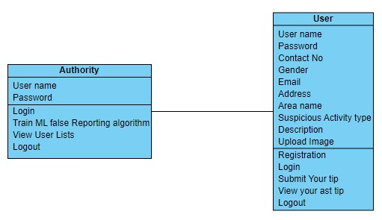

Fig:3.6 Class Diagram

**SEQUENCE DIAGRAM**

* A sequence diagram in Unified Modeling Language (UML) is a kind of interaction diagram that shows how processes operate with one another and in what order.
* It is a construct of a Message Sequence Chart. Sequence diagrams are sometimes called event diagrams, event scenarios, and timing diagrams

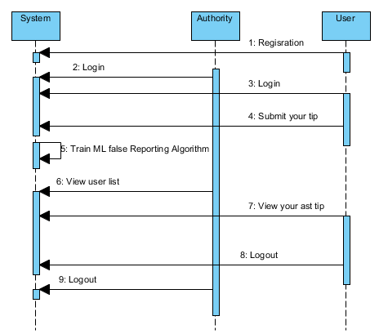

Fig:3.7 Sequence Diagram

**COLLABORATION DIAGRAM:**

In collaboration diagram the method call sequence is indicated by some numbering technique as shown below. The number indicates how the methods are called one after another. We have taken the same order management system to describe the collaboration diagram. The method calls are similar to that of a sequence diagram. But the difference is that the sequence diagram does not describe the object organization whereas the collaboration diagram shows the object organization.

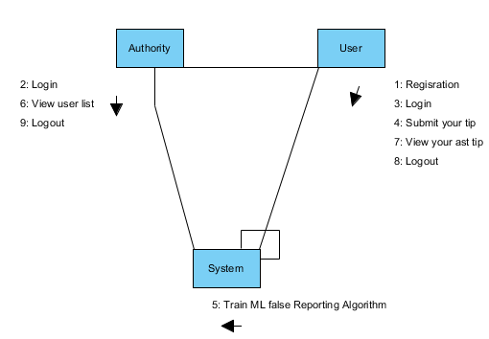

Fig:3.8 Collaboration Diagram

**DEPLOYMENT DIAGRAM**

Deployment diagram represents the deployment view of a system. It is related to the component diagram. Because the components are deployed using the deployment diagrams. A deployment diagram consists of nodes. Nodes are nothing but physical hardware’s used to deploy the application.

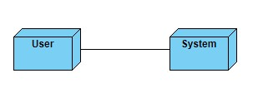

Fig:3.9 Deployment Diagram

**ACTIVITY DIAGRAM:**

Activity diagrams are graphical representations of workflows of stepwise activities and actions with support for choice, iteration and concurrency. In the Unified Modeling Language, activity diagrams can be used to describe the business and operational step-by-step workflows of components in a system. An activity diagram shows the overall flow of control.

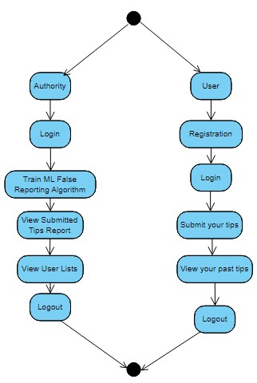

Fig:3.10Activity Diagram

**COMPONENT DIAGRAM**:

A component diagram, also known as a UML component diagram, describes the organization and wiring of the physical **c**omponents in a system. Component diagrams are often drawn to help model implementation details and double-check that every aspect of the system's required function is covered by planned development.

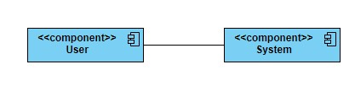

Fig:3.11 Component Diagram

**ER DIAGRAM:**

An Entity–relationship model (ER model) describes the structure of a database with the help of a diagram, which is known as Entity Relationship Diagram (ER Diagram). An ER model is a design or blueprint of a database that can later be implemented as a database. The main components of E-R model are: entity set and relationship set.

An ER diagram shows the relationship among entity sets. An entity set is a group of similar entities and these entities can have attributes. In terms of DBMS, an entity is a table or attribute of a table in database, so by showing relationship among tables and their attributes, ER diagram shows the complete logical structure of a database. Let’s have a look at a simple ER diagram to understand this concept.

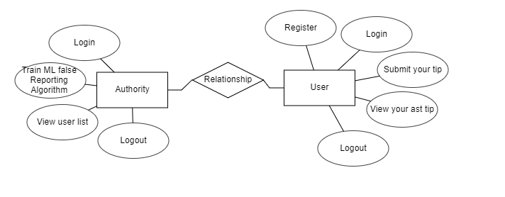

Fig:3.12 ER Diagram

**DFD DIAGRAM:**

A Data Flow Diagram (DFD) is a traditional way to visualize the information flows within a system. A neat and clear DFD can depict a good amount of the system requirements graphically. It can be manual, automated, or a combination of both. It shows how information enters and leaves the system, what changes the information and where information is stored. The purpose of a DFD is to show the scope and boundaries of a system as a whole. It may be used as a communications tool between a systems analyst and any person who plays a part in the system that acts as the starting point for redesigning a system.

**DFD LEVEL-1 DIAGRAM**

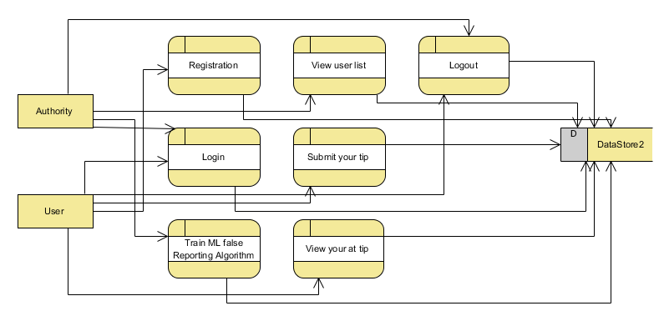

Fig:3.13 DFD Level-1 Diagram

**DFD LEVEL-2 DIAGRAM**

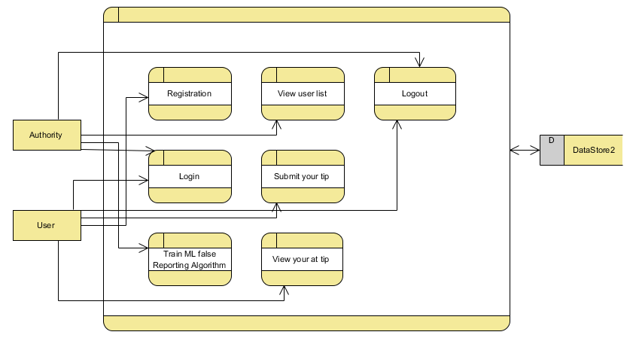

Fig:3.14 DFD Level-2 Diagram

**CHAPTER 4**

**IMPLEMENTATION**

**4.1 ENVIRONMENT SETUP**

**4.1.1** **PYTHON 3.7.0 INSTALLATION**

The following steps outline how to download and install Python 3.7.0:

**Step 1)** Visit the official Python website at [python.org](https://www.python.org/downloads/release/python-370/).Choose the appropriate installer for your Windows operating system architecture (32-bit or 64-bit).

**Step 2)** Once the installer is downloaded, locate the file in your Downloads folder. Double-click on the installer file (python-3.7.0-amd64.exe for 64-bit or python-3.7.0.exe for 32-bit) to launch the installation wizard.

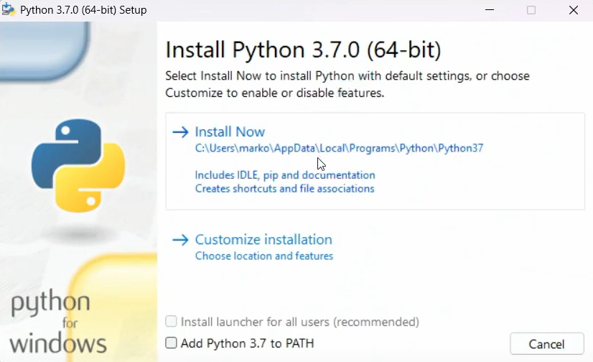

Fig: 4.1 Python Setup Wizard

**Step 3)** In the Python Setup wizard, ensure that the option to "Add Python 3.7 to PATH" is selected. This option is crucial for allowing Python to be easily accessible from the command line. Click "Install Now" to proceed.

**Step 4)** Follow the prompts in the installation wizard to complete the installation process. The installer will copy necessary files and configure Python on your system. This may take a few minutes.

**Step 5)** After installation, open Command Prompt (Press Windows key + R type cmd, and press Enter to open Command Prompt). In the Command Prompt window, type the following command and press Enter: **python --version**

**Step 6)** You should see Python 3.7.0 (or a similar version number) displayed, confirming the successful installation of Python.

**4.1.2 NODE.JS V12.13.1 INSTALLATION**The Following are the Node.js v12.13.1 Installation Steps for Windows:

**Step 1)** Navigate to the official Node.js website at <https://nodejs.org/en/download/releases/>. Download the Node.js v12.13.1 installer for Windows.

**Step 2)** Once the installer is downloaded, locate the file in your Downloads folder. Double-click on the downloaded installer file to run the installation wizard.

**Step 3)** During the installation process, you will be prompted to accept the license agreement. Read through the agreement and proceed by accepting it.

**Step 4)** In the installation wizard, you may encounter various options. Ensure that the option to add Node.js to the system PATH is selected for easier command-line usage.

**Step 5)** Follow the prompts in the installation wizard to complete the installation process. Once finished, Node.js v12.13.1 will be installed on your Windows system.

**Installation of Required Python Packages and NLTK Packages**

To Install the Required Python Packages:

* Locate the requirements.txt file containing a list of Python packages required for your project.
* Open Command Prompt (Windows). Navigate to the directory containing the requirements.txt file using the cd command.
* Execute the following command to install the required packages: **pip install -r requirements.txt**
* This command will automatically install all the Python packages listed in the requirements.txt file.

To Install NLTK Packages:

* Locate and double-click on the **installNLTK.bat** file included in your project.
* A window will appear with an option to download NLTK packages. Click on the "Download" button to initiate the installation process.
* Once the installation is complete, the window will turn green, indicating successful installation.
* You can then safely close the window and proceed with the next steps of your project.

**Blockchain Data Security Implementation:**

Utilizing Blockchain, each data record is stored as a tamper-proof block with a unique hash code. Verification of previous block hash codes ensures data integrity. Smart Contracts, coded in Solidity, facilitate data storage and retrieval on the Blockchain. This robust system secures user data effectively, enhancing trust and reliability.

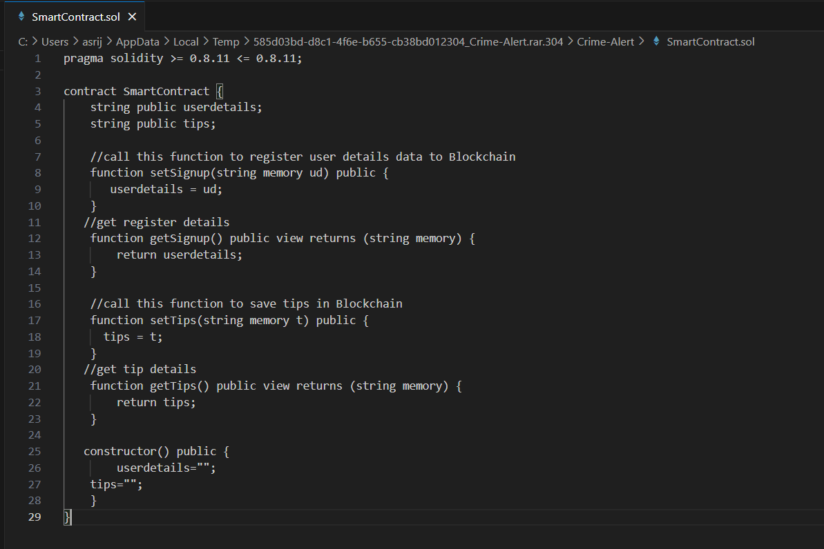

Fig: 4.2 SmartContract.sol File

In above contract we have define function to save and get user and their TIP details and we need to deploy above contract in Ethereum tool using below steps

1. First go inside ‘hello-eth/node-modules/bin’ folder and then find and double click on ‘runBlockchain.bat’ file to start Ethereum tool and then will get below screen

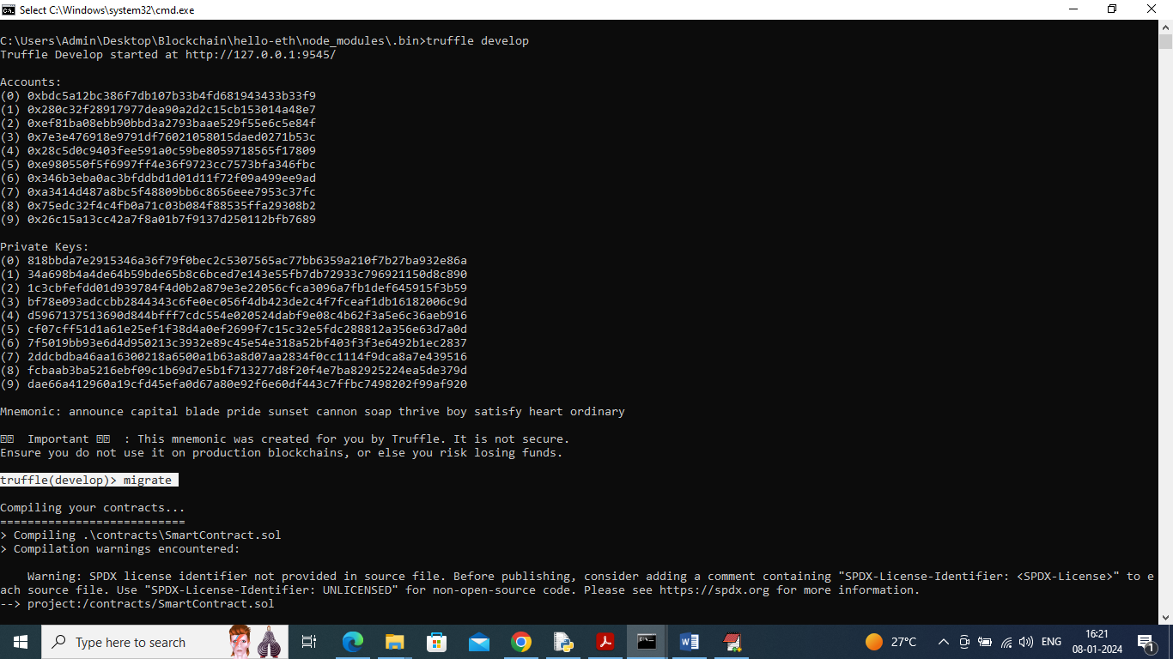

Fig: 4.3 Ethereum Startup

1. In above screen Ethereum tool started with default private keys and account and now type command as ‘migrate’ and press enter key to deploy contract and then will get below page

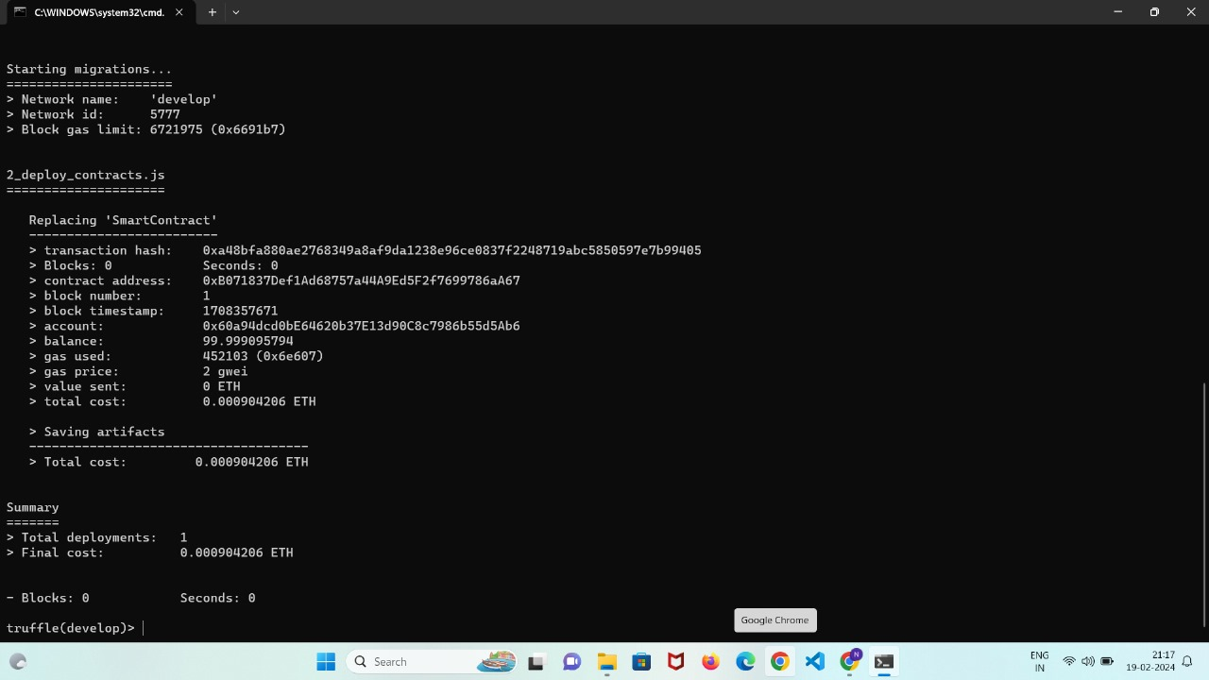

Fig: 4.4 Contract Deployed

1. In above screen we can see ‘Smart Contract’ deployed and got contract address also and this address need to specify in python code to save and get details from Ethereum and in below screen showing python code calling smart contract using

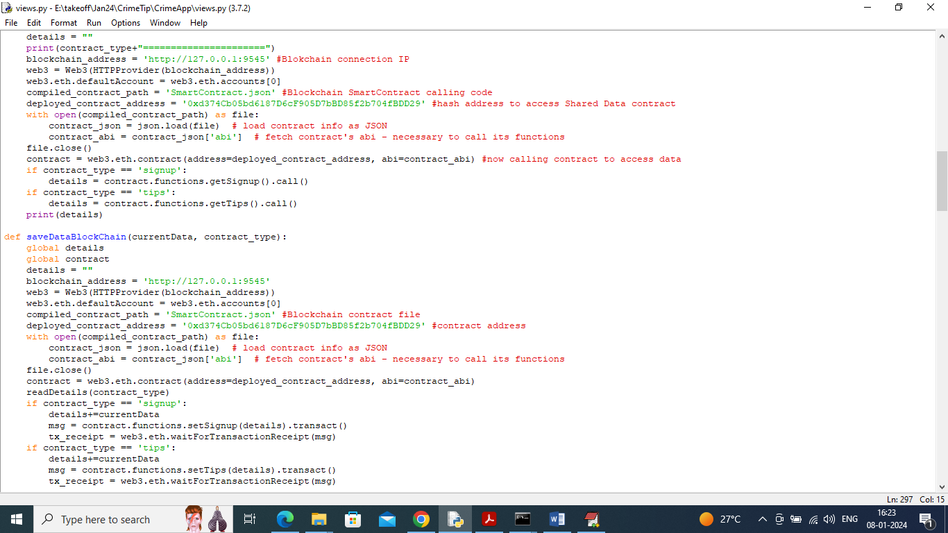

Fig: 4.5 Contract Calling

1. In above screen read red color comments to know about contract calling using python and now contract is deployed and let it run.

**Data Storage and ML Algorithm Training:**IPFS for Multimedia Data Storage:

Utilize the IPFS (InterPlanetary File System) server to store multimedia data. Upon storage, retrieve a hash code representing the file location, which is then saved in the Blockchain. This hash code is subsequently employed for file retrieval from IPFS.TIP Dataset for ML Algorithm:

Employ the TIP dataset for training the machine learning algorithm. The dataset comprises TIP descriptions, with the first-row denoting column names and subsequent rows representing dataset values. The final column indicates the class label, with '0' signifying a true 'Crime TIP Description' and '1' indicating false.

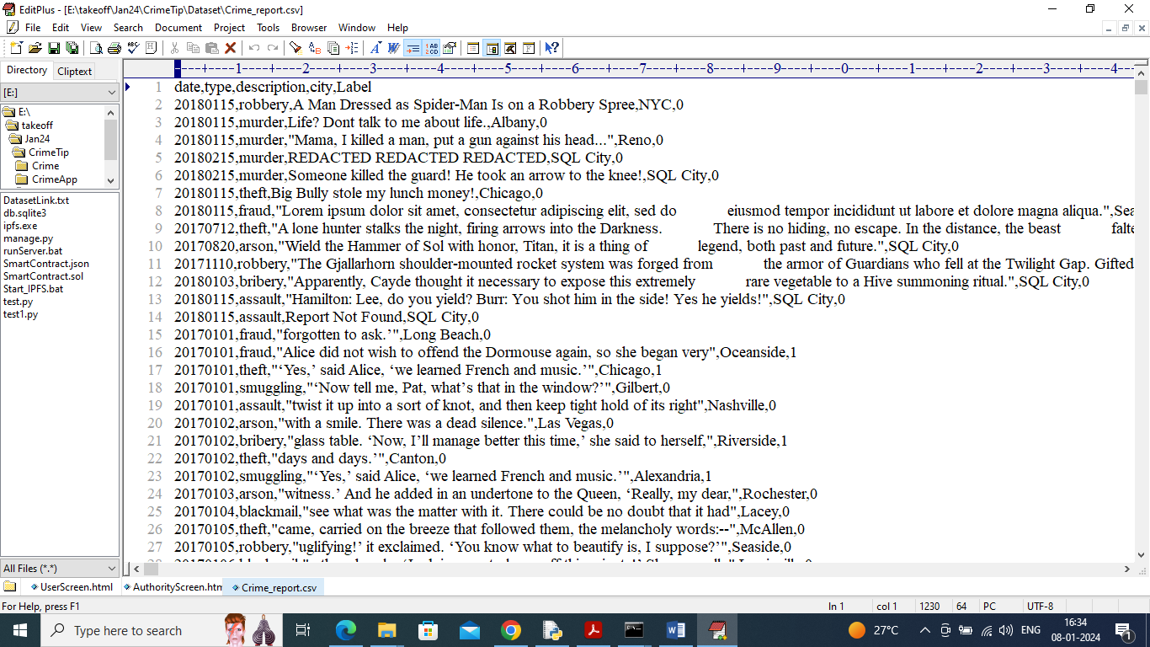

Fig: 4.6 Dataset Overview

In above dataset screen first row represents dataset column names and remaining rows represents dataset values and in last column we have class label as 0 and 1 where 0 means ‘Crime TIP Description’ is true and 1 means False.

**Steps For Executing the Project:**

1. To run project first double, click on ‘runIPFS.bat’ file to start IPFS server and get below page

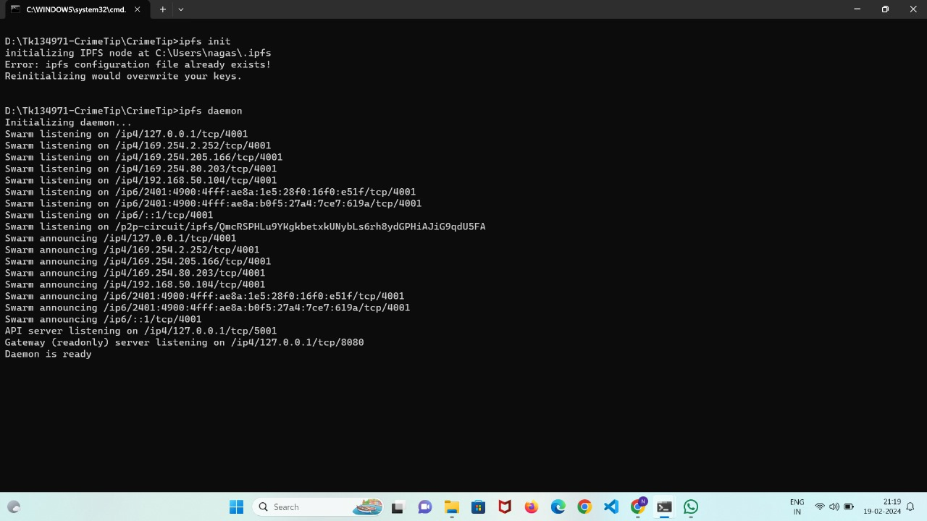

Fig: 4.7 IPFS Startup

1. In above screen IPFS server started and now double click on ‘runServer.bat’ file to start python web server and will get below page

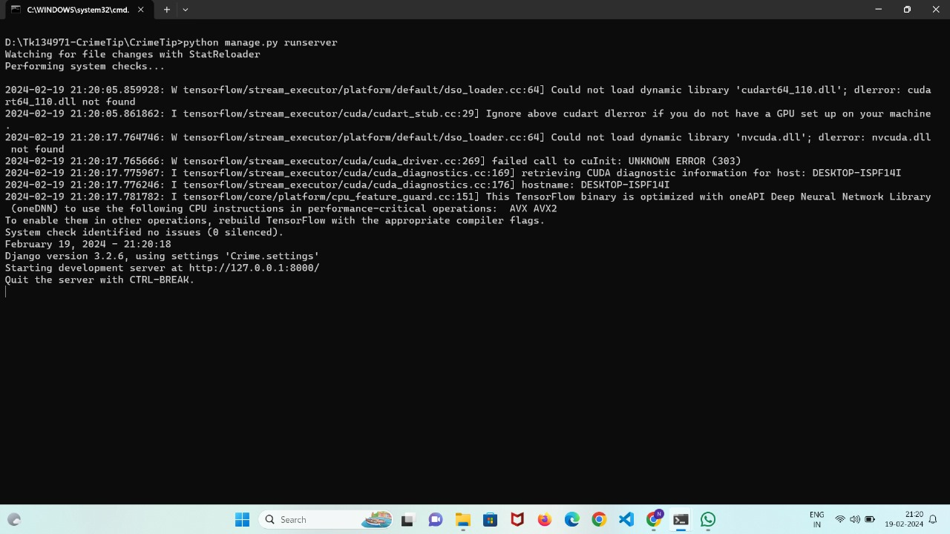

Fig: 4.8 Python Webserver Startup

1. In above screen python web server started and now open browser and enter URL as [http://127.0.0.1:8000/](http://127.0.0.1:8000/index.html) to access the Crime Alert Web Application.

* Top of Form

**CHAPTER 5**

**RESULT**

In our Crime Alert: An Anonymous Crime Reporting System project, anonymity and confidentiality within the system are ensured through the implementation of a **unique ID generation** mechanism. Each crime report is assigned a distinct identifier, safeguarding the identities of both reporters and subjects involved in reported incidents. This anonymity protection fosters a secure environment for reporting sensitive information without fear of retribution or exposure.

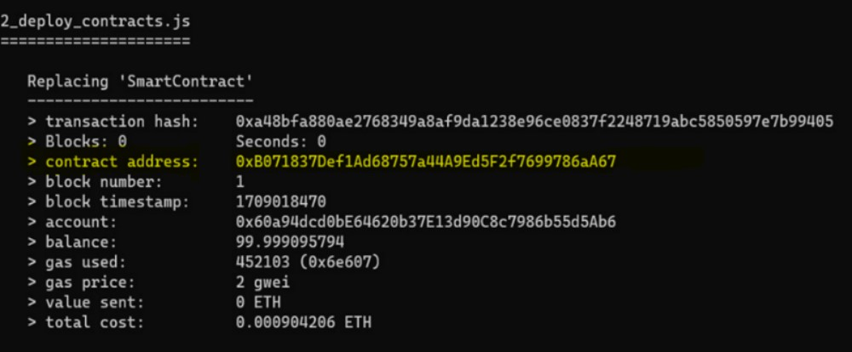

Fig:5.1 Unique Id Generation

And The implementation of **TensorFlow CNN algorithm** efficiently preprocesses text data, performs word embedding, and partitions data for training, validation, and testing. The trained model accurately distinguishes between true and false crime reports, enhancing the reliability and effectiveness of our Crime Alert system.

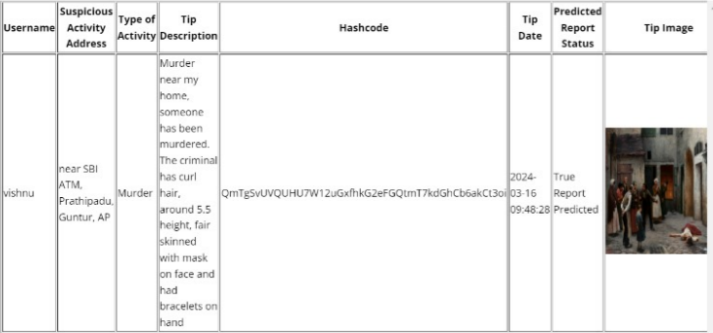

Fig:5.2 Prediction of the crime report

The model achieves an exceptional accuracy rate of 99.19%, indicating its proficiency in correctly classifying crime reports as true or false. This high accuracy demonstrates the reliability of the system in distinguishing between genuine incidents and false alarms, thereby enhancing the credibility of reported information.

With a precision score of 96.46%, the system exhibits a low false positive rate, accurately identifying true crime reports while minimizing misclassifications. High precision ensures that legitimate incidents are effectively recognized and acted upon, reducing the likelihood of erroneous conclusions or responses.

The recall score of 199.45% signifies the system's capability to capture a significant portion of true crime reports among all actual positive instances. This high recall rate reflects the system's sensitivity to identifying genuine incidents, thereby maximizing the coverage of reported crimes and facilitating appropriate intervention measures.



Fig:5.3 TensorFlow CNN Metrics

The F1 score, calculated at 98.94%, represents a harmonized measure of the system's precision and recall performance. This balanced evaluation metric underscores the system's effectiveness in simultaneously achieving high precision and recall, ensuring robustness and reliability in crime report classification.

**5.1 OUTPUT SCREENS**

**Modules**

**New User Sign up:** using this module user can sign up with the application

**User Login:** using this module user can login to application and all user details will be managed with server in AES encrypted format

**Submit your** **Tip:** after login using this module user can submit tip about any suspicious activities

**View your Past Tips:** using this module user can view all submitted tip reports

**Authority Login:** authority can login to system using username and password as ‘admin’. After login authority can perform following options

**Train ML:** using this module authority can train ML to predict weather submitted tip is false or true

**View Submitted Tips Report:** using this module authority can view all submitted tips and machine learning predicted top status as true or false

**View User Lists:** using this module authority can view all registered user details but all username will be anonymised for security reason

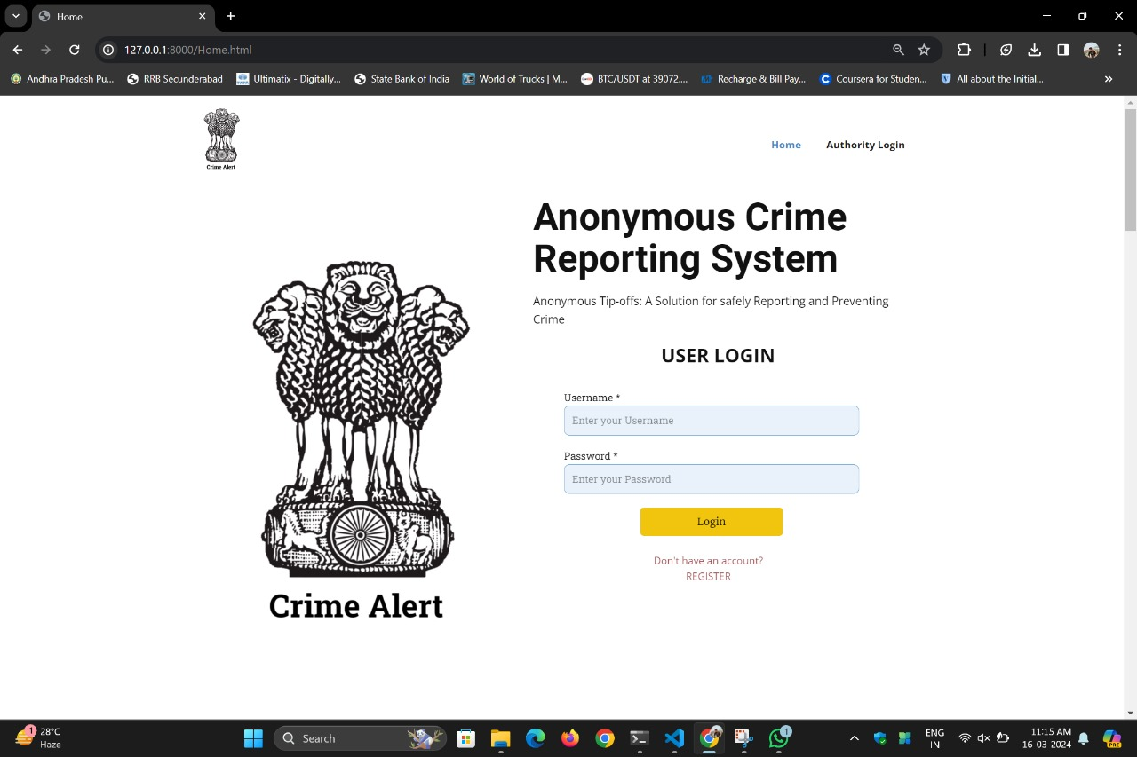

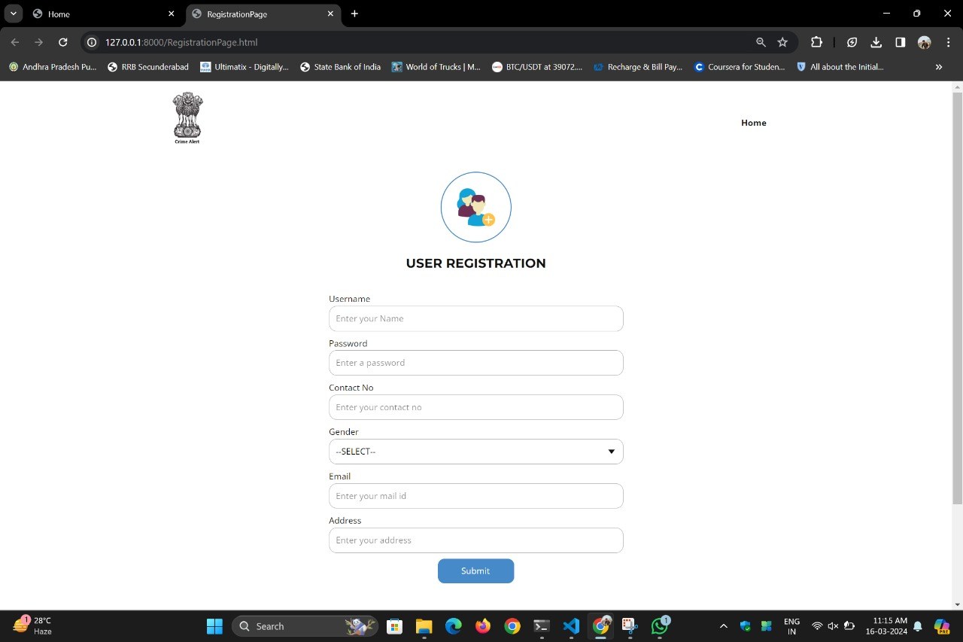

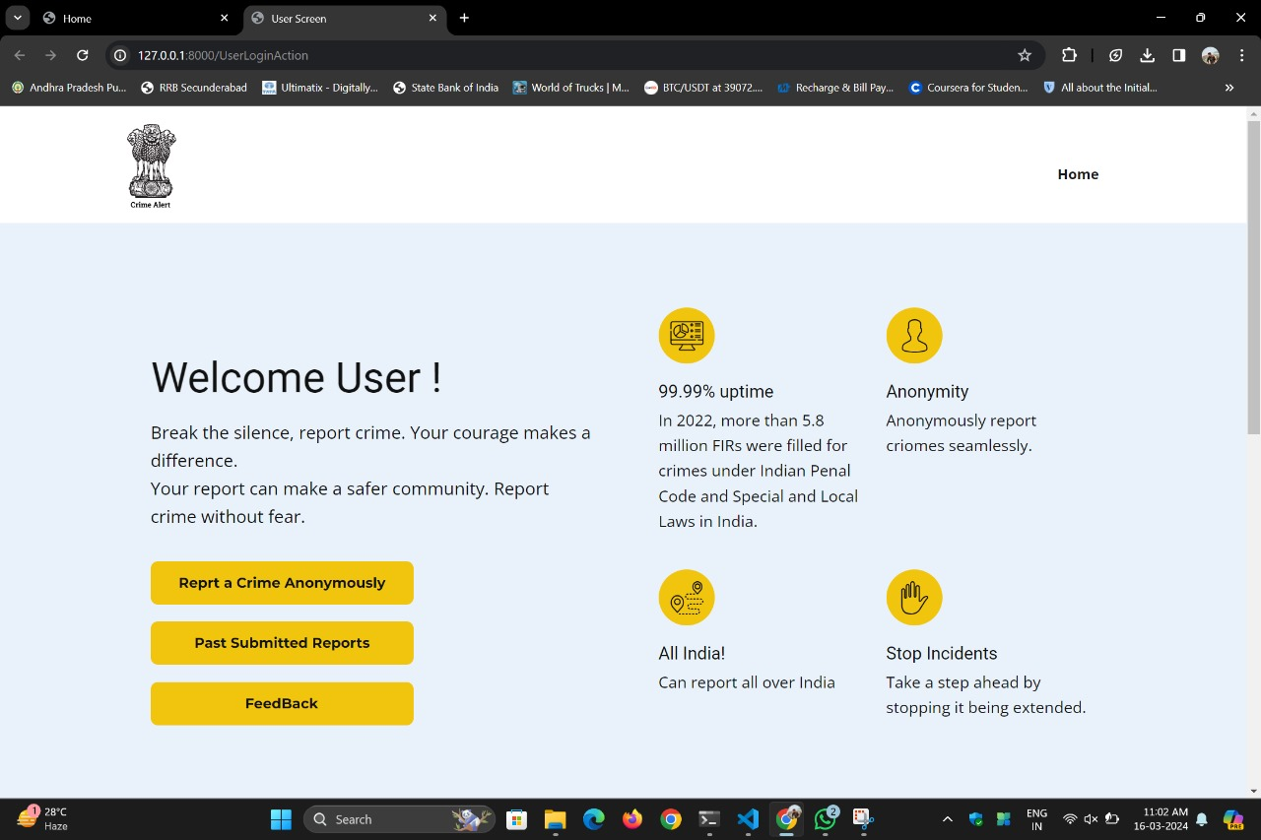

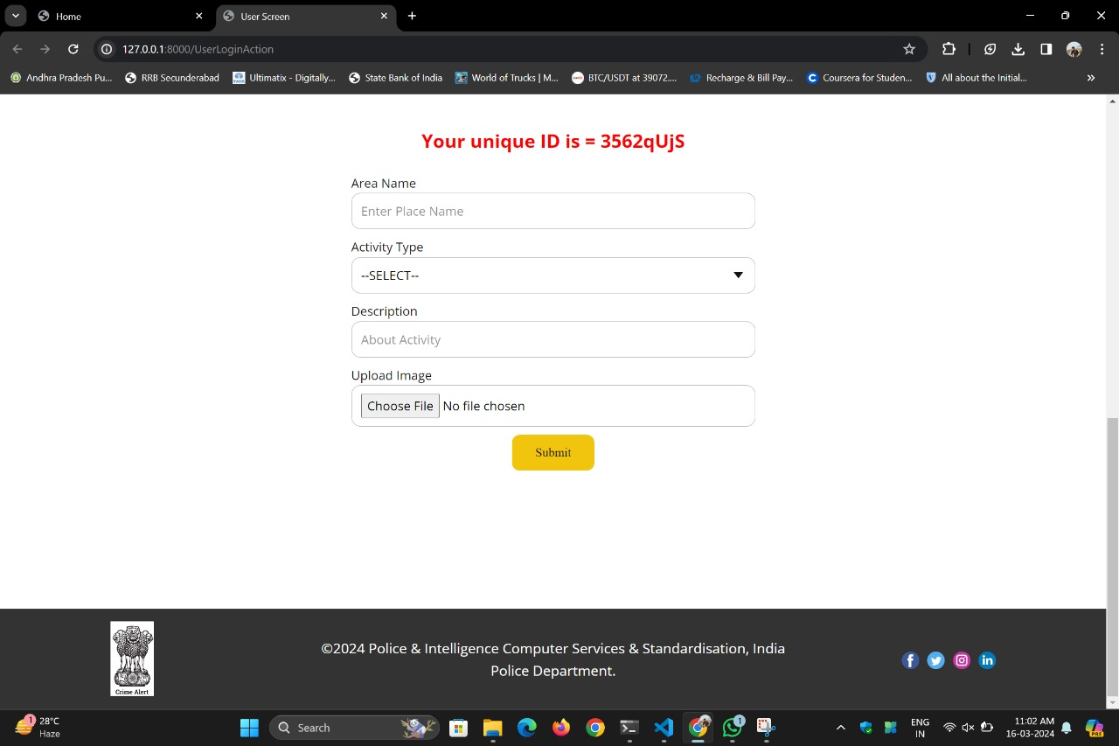

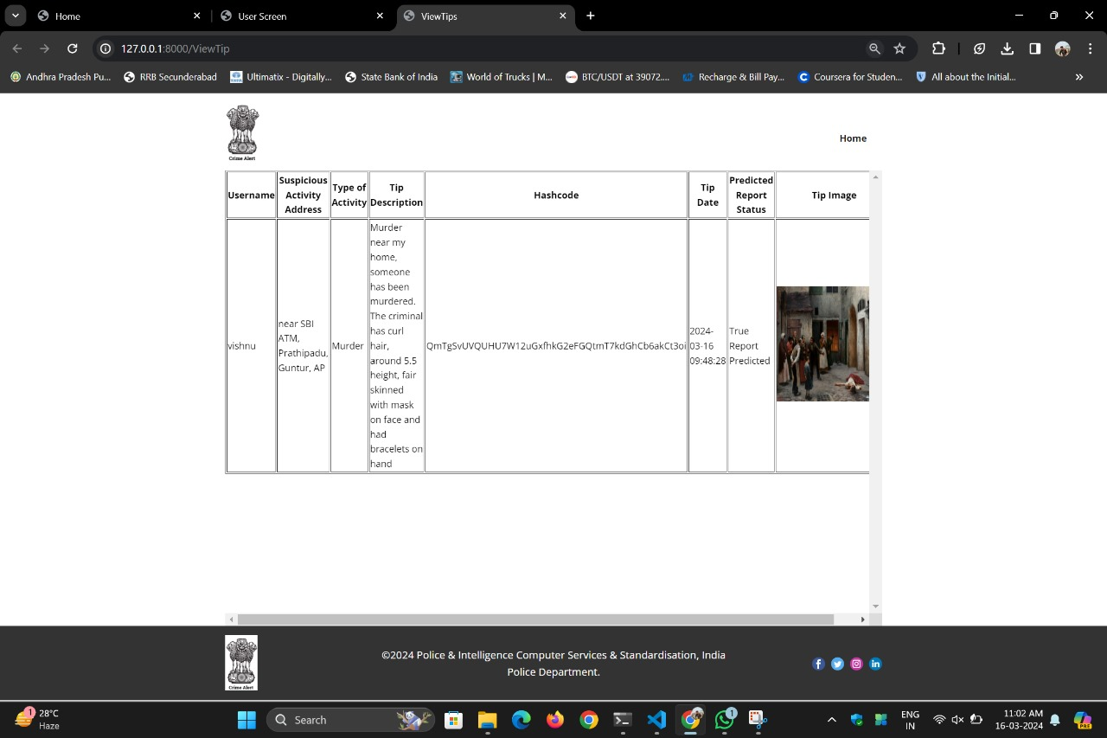

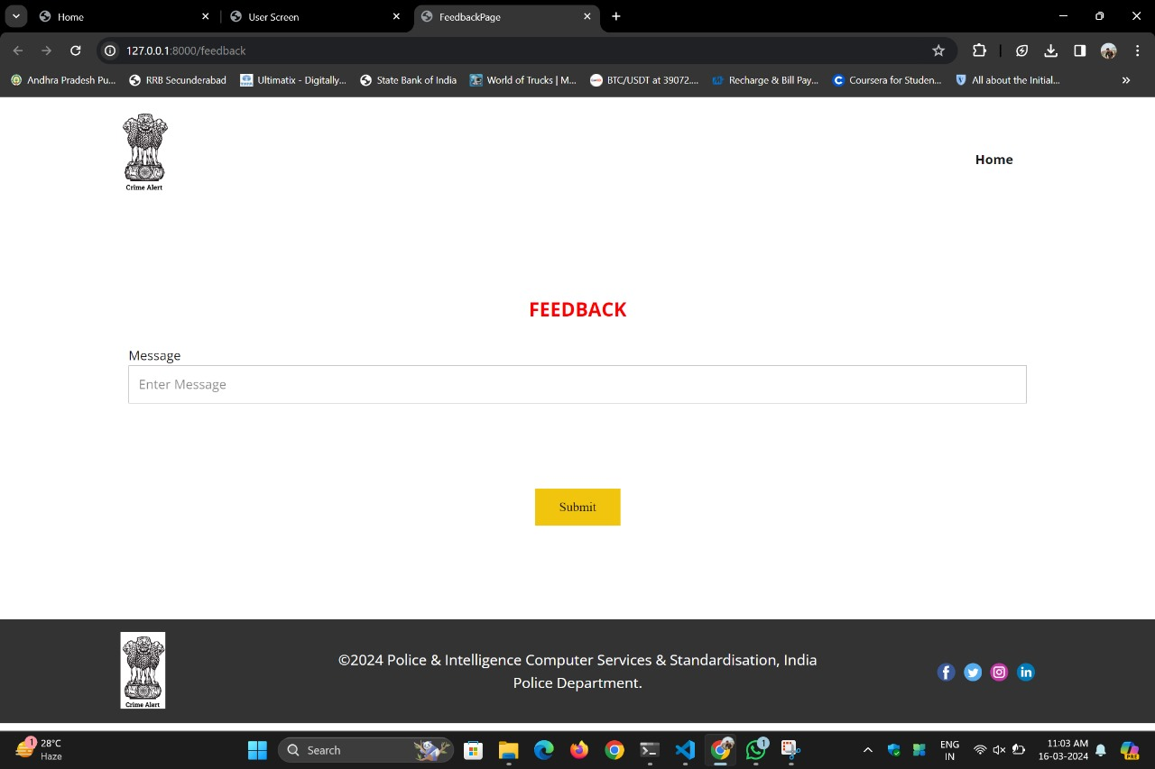

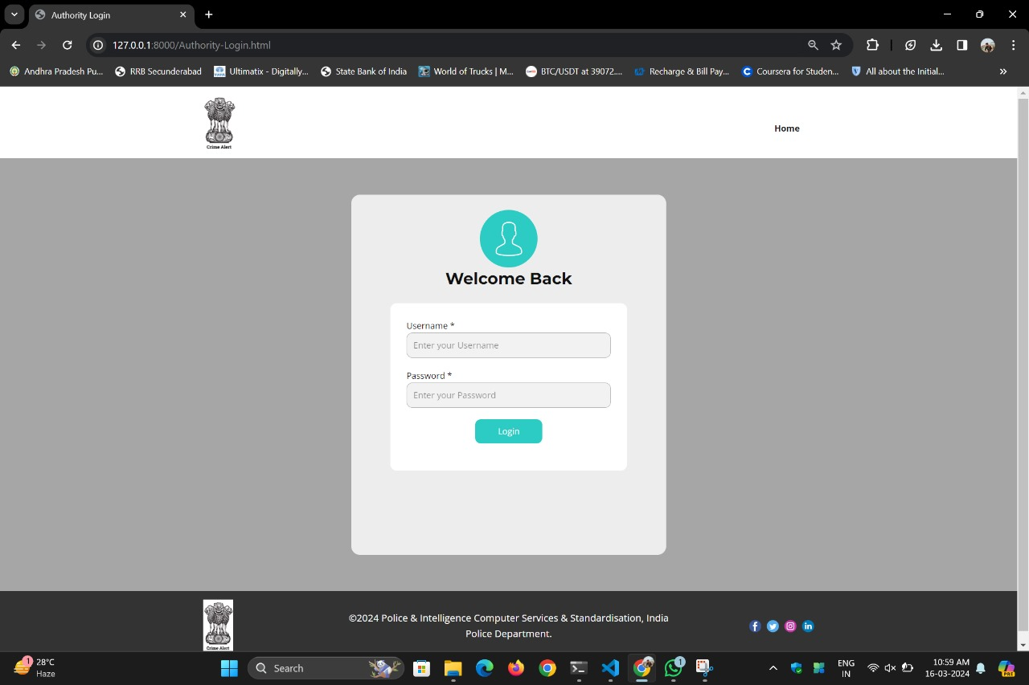

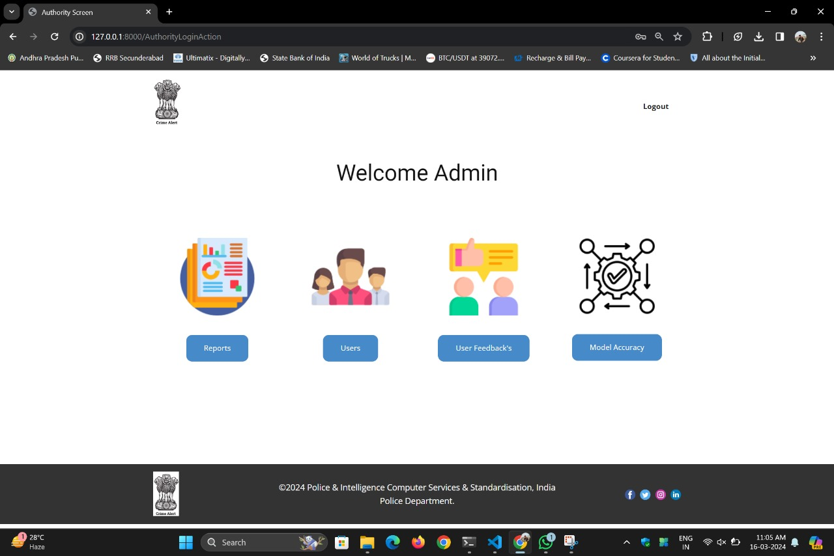

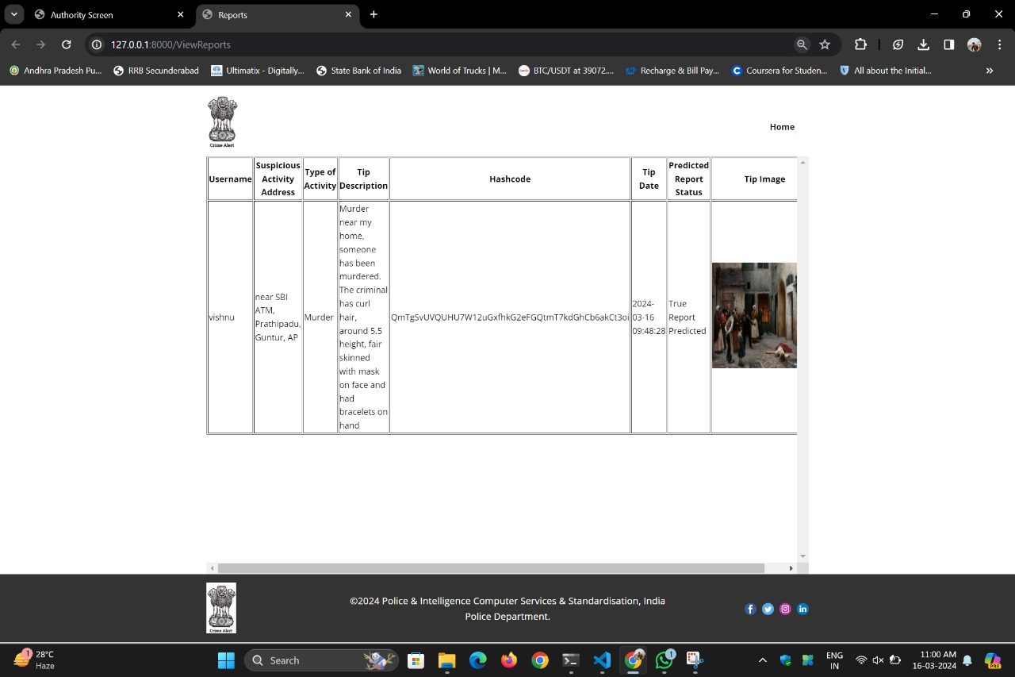

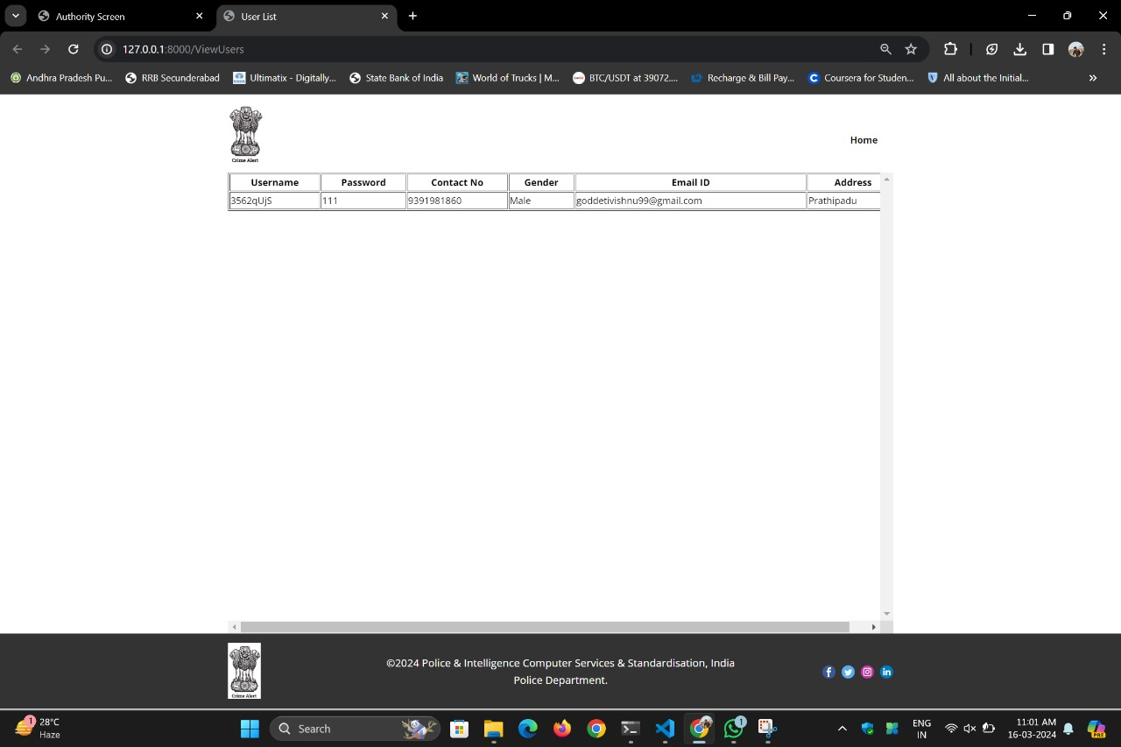



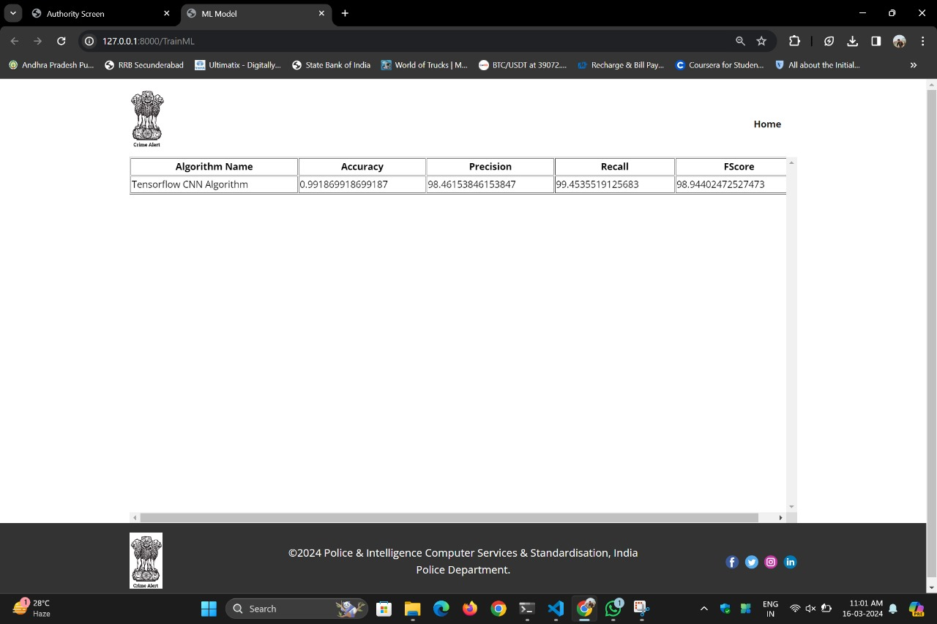

**CHAPTER 6**

**CONCLUSION AND FUTURE SCOPRE**

The Crime Alert: An Anonymous Crime Reporting System project signifies a significant stride in simplifying and securing the reporting of crimes. Utilizing advanced technologies such as Convolutional Neural Networks and Blockchain Ethereum, it ensures that individuals can report criminal activities without fear of their safety or privacy being compromised.

The primary aim is to establish a safe platform where whistleblowers and witnesses can speak up without the threat of retaliation. Additionally, it assists law enforcement agencies in better understanding and responding to reported crimes through data analysis. By employing sophisticated algorithms and secure record-keeping methods, the Crime Alert system provides a reliable means of categorizing and tracking reported incidents, fostering trust between users and authorities and promoting transparency and accountability in the reporting process. Prioritizing user anonymity and data integrity, the project promotes a culture of community safety and collaboration, demonstrating how technology can be harnessed for positive social impact.

The future development of the Crime Alert: An Anonymous Crime Reporting System aims to enhance user empowerment and refine analytical capabilities. One significant enhancement is the integration of AI-powered chatbots to streamline the reporting process, making it more accessible and engaging.

Furthermore, incorporating multi-modal reporting options such as mobile apps and SMS promotes inclusivity and ensures widespread participation, accommodating diverse user preferences and accessibility needs. Additionally, the system will leverage Natural Language Processing (NLP) algorithms to extract deeper insights from reported data, enabling a more nuanced understanding of the information provided. Integration of decentralized identity verification systems will strengthen user anonymity while preserving data integrity, enhancing user confidence and the reliability of reported information. These enhancements reflect Crime Alert's commitment to continuous improvement, striving to enhance efficiency, accessibility, and accuracy in handling reported incidents, ultimately contributing to the creation of safer and more secure communities.

**CHAPTER -7**

**REFERENCES**

[1]. Yao Du, Shuxiao Miao, Zitian Tong, Victoria Lemieux & Zehua Wang “Blockchain-Empowered Mobile Edge Intelligence, Machine Learning and Secure Data Sharing” - March 2021

[2]. Vishal A. Kharde & S.S. Sonawane, “Sentiment Analysis of Twitter Data: A Survey of Techniques” - April 2016

[3]. Jasleen Kaur and Dr. Jatinderkumar R. Saini “A Study of Text Classification Natural Language Processing Algorithms for Indian Languages” - – July 2015

[4]. ArcharnaM, Durga S, Saveetha K “Online Crime Reporting System”

[5]. Riya Lohan and Mr.Mahesh Singth, “ An Online Crime Reporting System” – Research Paper- June 2015

[6] B. Holtmann, and Domingo-Swarts, “Current trends and responses to crime in South Africa. Crime,” Violence and Injury Prevention in South Africa, 2008, pp 105 - 129.

[7] G. Paula, “Crime-fighting sensors.” Mechanical Engineering Magazine Select Articles, 120 (01), 1998. pp.66-68.

[8] Kovács, L., Szlávik, Z., Benedek, C., Havasi, L., Petrás, I., Losteiner, D., Utasi, Á., Liscár, A., Czúni, L. and Szirányi, T., “Video Surveillance Framework for Crime Prevention and Event Indexing,” in ICT4Justice, January 2008.

[9] H. Van Vuuren, “Small bribes big challenge: Extent and nature of petty corruption SouthAfrica” South African Crime Quarterly, (9), 2004.

[10] Diva Lal, Adiba Abidin, Naveen Garg, and Vikas Deep. “Advanced immediate crime reporting to police in India.” Procedia Computer Science, 85:543–549, 2016.

[11] Tzay-Farn Shih, Chin-Ling Chen, Bo-Yan Syu, andYong-Yuan Deng. A cloud-based crime reporting system with identity protection. Symmetry, 11(2):255, 2019.

**APPENDIX**

**Published Article Certificates **









**Published Article in the Journal**